CSS BRITISH HISTORY · TOPIC 7 · QUESTION ANSWERS
Edwardian Britain, the Great War and the Road to 1939
Every past question on the Edwardian Labour movement, the First World War, Kitchener, interwar foreign policy and the League of Nations — answered in full, in simple words, with answer maps

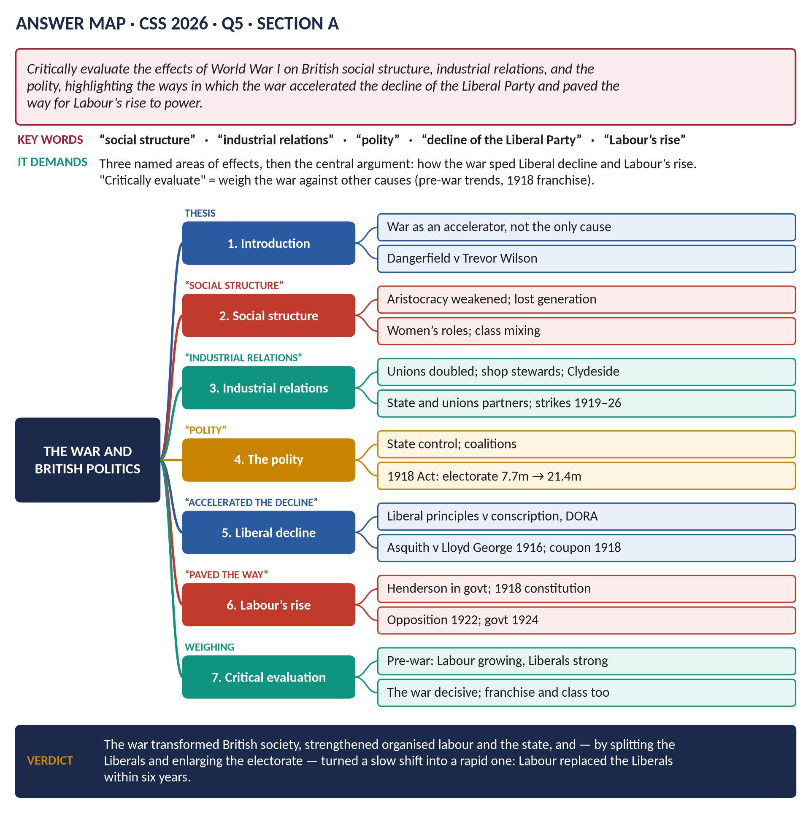
All 8 past items (2015–2026): seven full answers and one short note; the six past MCQs solved; five predicted questions with outlines.
Topic 7 of 10 · companion to T7KB (the Knowledge Base)
Contents
HOW TO USE THIS · Updating the contents
Right-click the contents → Update Field → Update entire table, before saving as PDF.

How to Use These Answers 6
Answer 1 · The Edwardian Era and the Rise of the Labour Movement 7
The model answer 8
Introduction 8
Part 1 · What was the Edwardian era? 8
(1) Dates and name 8
(2) Its character 8
Part 2 · The rise of the Labour movement 9
(3) The starting point in 1901 9
(4) Taff Vale (1901) — the turning point 9
(5) The Gladstone–MacDonald pact (1903) 9
(6) The breakthrough of 1906 9
(7) Growth and setbacks (1906–1914) 9
(8) The Great Unrest (1910–1914) 9
Part 3 · The significance of the Labour movement 10
(9) An independent working-class voice 10
(10) It pushed the Liberals to reform 10
(11) It changed the basis of politics 10
(12) It showed the power of organised labour 10
(13) It laid foundations for the future 10
(14) Its limits 10
Answer 2 · The Rise of the Labour Party and Its Achievements 12
The model answer 13
Introduction 13
Limb 1 · The rise of the Labour Party 13
(1) Origins (before 1900) 13
(2) The Labour Representation Committee (1900) 14
(3) The Edwardian breakthrough (1901–1914) 14
(4) The First World War (1914–1918) 14
(5) The party of opposition and government (1918–1931) 14
(6) Recovery and triumph (1931–1945) 14
Limb 2 · The achievements of the Labour Party 15
(7) Before 1945 15
(8) The Attlee government (1945–1951) — the greatest achievements 15
(9) Later Labour governments 16
Answer 3 · The Causes of World War I and Its Social and Economic Effects on Britain 17
The model answer 18
Introduction 18
Limb 1 · The causes 18
(1) Militarism 18
(2) Alliances 19
(3) Imperialism 19
(4) Nationalism 19
(5) The crises (1905–1913) 19
(6) The July Crisis (1914) 19
(7) Why Britain entered 20
Limb 2 · The effects on Britain 20
(8) Social effects 20
(9) Economic effects 21
Answer 4 · Kipling's Two Divisions: Was British Policy in the First World War Justified? 23
The model answer 24
Introduction 24
The quotation 24
(1) What Kipling meant 24
(2) How widespread the feeling was 24
Was British policy justified? — the case for 25
(3) Going to war was justified 25
(4) Some conduct was justified 25
Was British policy justified? — the case against 25
(5) Doubts about going to war 25
(6) The conduct of the war 25
(7) Making the peace 26
(8) What Kipling's words teach 26
Answer 5 · The War, British Society and Politics — the Liberal Fall and the Labour Rise 28
The model answer 29
Introduction 29
(1) Effects on social structure 29
(2) Effects on industrial relations 30
(3) Effects on the polity 30
How the war accelerated the decline of the Liberal Party 31
(4) The Liberals before 1914 — dying or healthy? 31
(5) The war and Liberal principles 31
(6) The Liberal split 31
(7) Trevor Wilson's image 31
How the war paved the way for Labour 31
(8) Labour gained from the war 31
(9) The results 32
Critical evaluation 32
(10) Weighing the war against other causes 32
Short Note 34
Lord Kitchener 34
Answer 6 · British Foreign Policy, 1919–1939 35
The model answer 36
Introduction 36
(1) The aims and the limits 36
Description — the five phases 36
(2) Phase 1 · 1919–1923: making the peace 36
(3) Phase 2 · 1924–1929: conciliation — "the spirit of Locarno" 36
(4) Phase 3 · 1929–1935: the Depression and the dictators 37
(5) Phase 4 · 1935–1938: appeasement 37
(6) Phase 5 · 1939: from appeasement to war 38
(7) Rearmament 38
Critical analysis 38
(8) What shaped the policy 38
(9) Successes 38
(10) Failures 38
(11) The historians' debate 39
Answer 7 · The League of Nations: Its Work and Its Failure 40
The model answer 41
Introduction 41
Limb 1 · What the League was 41
(1) Origins 41
(2) Aims 41
(3) Structure 42
(4) Powers — the sanctions of Article 16 42
(5) Membership 42
Limb 2 · The work of the League 42
(6) Political successes (the 1920s) 42
(7) Humanitarian and social work 43
(8) Failures 43
Limb 3 · The causes of its failure 43
(9) Structural weaknesses 43
(10) Membership problems 44
(11) The self-interest of Britain and France 44
(12) The Great Depression 44
(13) The dictators 44
(14) Linked to Versailles 44
(15) Its legacy 44
Part Two — The Past MCQs, Solved 46
CSS 2024 · MCQ 5 46
CSS 2024 · MCQ 6 46
CSS 2024 · MCQ 20 46
CSS 2025 · MCQ 9 46
CSS 2025 · MCQ 12 47
CSS 2026 · MCQ 18 47
Part Three — Five Predicted Questions, with Outlines 48
Predicted 1 · "Discuss the Liberal reforms of 1906–1914. Did they lay the foundations of the welfare state?" 48
Predicted 2 · "Examine the constitutional crisis of 1909–1911 and the significance of the Parliament Act." 48
Predicted 3 · "Assess the role of Britain in the Paris Peace Settlement of 1919." 48
Predicted 4 · "What were the causes and consequences of the General Strike of 1926?" 49
Predicted 5 · "Explain the impact of the Great Depression on Britain and the government's response." 49

How to Use These Answers
# | Paper | Question (short) | Answer
1 | 2021 Q5 | What is the Edwardian era? The rise and significance of the Labour movement | Answer 1
2 | 2022 Q4 | The rise of the Labour Party; enumerate its achievements | Answer 2
3 | 2021 Q4 | Causes of World War I; its social and economic effects on Britain | Answer 3
4 | 2023 Q5 | Kipling's "human beings and Germans" — was British policy in WWI justified? | Answer 4
5 | 2026 Q5 | Effects of WWI on society, industrial relations, polity; Liberal decline, Labour rise | Answer 5
6 | 2022 Q8(a) | Short note: Lord Kitchener | Short note
7 | 2015 P-II Q8 | British foreign policy 1919–1939 | Answer 6
8 | 2020 Q7 | The League of Nations: what it was, its work, why it failed | Answer 7

Every answer has: the question as set · its answer map · decoding the question (what the examiner wants, in plain words) · a model answer with numbered headings, figures and a verdict · why this answer scores.
TRAP — DO NOT FALL INTO IT · Same war, three different questions
The First World War has been asked three times: causes + social and economic effects (2021), was British policy justified? (2023), and effects on society, industrial relations and politics + the Liberal decline (2026). The facts overlap (T7KB Chapters 3–5), but each answer must be built on its own question's words. Likewise Labour in 2021 (the Edwardian movement, its significance) and 2022 (the whole rise and achievements).

HOW TO USE THIS · If you are new to this topic
Read T7KB Part Zero and Part One first. Every hard word is explained again inside the answers.

Answer 1 · The Edwardian Era and the Rise of the Labour Movement
THE QUESTION · CSS 2021 · Q5 · Section A · 20 marks
What is the Edwardian era? Elucidate the rise and significance of the Labour Movement in the Edwardian era.

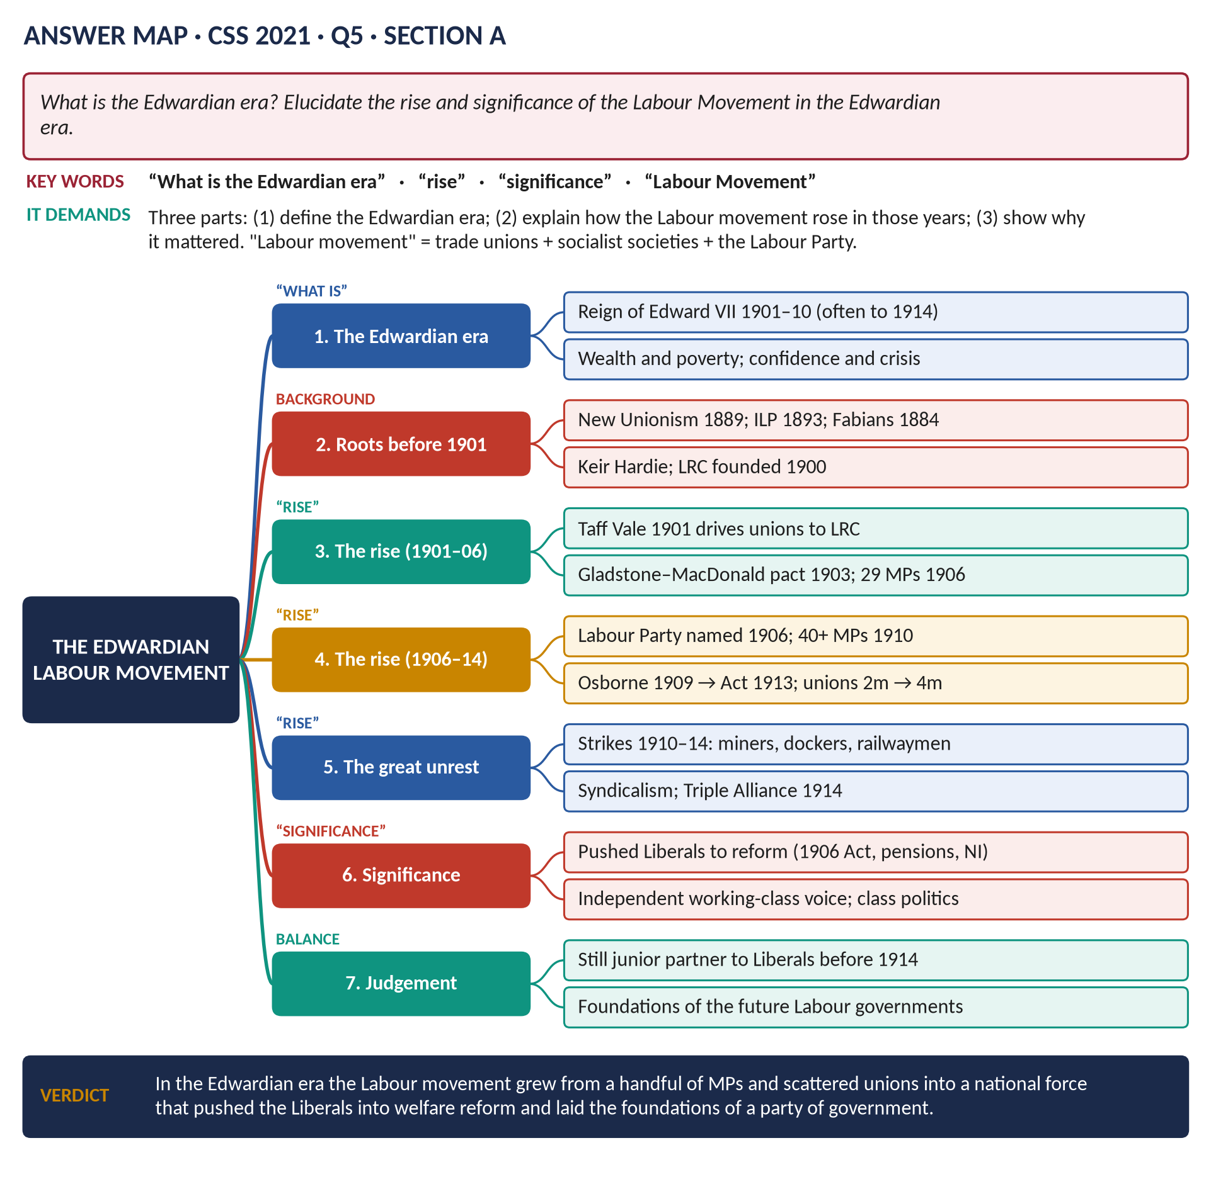
Figure 1 · The answer map for CSS 2021 · Q5 · Section A: every branch is one heading of the answer below.
DECODING THE QUESTION
Three parts. (1) "What is the Edwardian era?" — a clear definition with its dates and character. (2) "Elucidate the rise … of the Labour Movement" — explain how it grew, step by step, in those years. (3) "… and significance" — why it mattered. The Labour movement means more than the party: trade unions, socialist societies and the Labour Party together. Keep the focus on 1901–1914; earlier roots and later results only briefly.

The model answer

Introduction
The Edwardian era is the name given to the reign of King Edward VII (1901–1910), and often, more loosely, to the whole period from Queen Victoria's death to the outbreak of the First World War (1914). It was an age of great wealth and confidence, but also of deep poverty and rising conflict. In these years the Labour movement — the trade unions, the socialist societies and the new Labour Party — grew from a handful of MPs and scattered unions into a national force. Its significance was great: it gave the working class an independent political voice, pushed the Liberals into major social reform, and laid the foundations of a future party of government.

Part 1 · What was the Edwardian era?

(1) Dates and name
- Strictly: 22 January 1901 (death of Victoria) to 6 May 1910 (death of Edward VII).
- Loosely: to August 1914 — the years between the Victorian age and the Great War.
- Edward VII, "the Uncle of Europe", was sociable and pleasure-loving; his visit to Paris (1903) helped the Entente Cordiale.

(2) Its character
Feature | Explanation
Wealth and splendour | Country houses, motor cars, the music hall; Britain at the height of its imperial power.
Poverty | Rowntree (York, 1901) and Booth (London) found about 30 per cent living in poverty — caused mainly by low wages, old age, sickness and unemployment.
Reform | The Liberal reforms (1906–14): pensions, National Insurance, school meals.
Conflict | Suffragettes, the Great Unrest of strikes, the House of Lords crisis, Ulster.
Danger abroad | The naval race with Germany; the ententes with France (1904) and Russia (1907).

Part 2 · The rise of the Labour movement

(3) The starting point in 1901
- Unions: about 2 million members, strengthened by "New Unionism" among unskilled workers (the Dock Strike, 1889).
- Socialist societies: the SDF (1881), the Fabians (1884), the Independent Labour Party (1893, Keir Hardie).
- The Labour Representation Committee (LRC), founded on 27 February 1900 by unions and socialists to elect working men to Parliament; secretary Ramsay MacDonald. In 1900 it won only 2 seats.

(4) Taff Vale (1901) — the turning point
The House of Lords ruled that the railway workers' union could be sued for the losses caused by a strike; it paid £23,000. No union's funds were safe. Unions concluded they needed their own MPs to change the law: LRC membership rose from about 350,000 to nearly 1 million by 1903.

(5) The Gladstone–MacDonald pact (1903)
A secret agreement: the Liberals would not run candidates against the LRC in about 30 seats, so as not to split the anti-Conservative vote.

(6) The breakthrough of 1906
- The LRC won 29 seats and renamed itself the Labour Party, with Keir Hardie as its chairman.
- Its first great success: the Liberal government's Trade Disputes Act (1906), which reversed Taff Vale.

(7) Growth and setbacks (1906–1914)
- 1908–09: the powerful Miners' Federation joined the party.
- 1909: the Osborne judgment forbade unions to spend money on politics — a blow to Labour's finances.
- 1910: 40 MPs in January, 42 in December.
- 1911: payment of MPs (£400 a year) allowed working men to sit in Parliament.
- 1913: the Trade Union Act allowed unions a political fund, with members free to opt out.

(8) The Great Unrest (1910–1914)
- Huge strikes: the Tonypandy riots (1910); national dock and railway strikes (1911); the national coal strike (1912), which won a minimum-wage law.
- Syndicalism: some workers believed unions should take over industry by strikes.
- The "Triple Alliance" of miners, railwaymen and transport workers (1914).
- Union membership rose to about 4 million by 1914.
Year | Step in the rise
1900 | LRC founded; 2 MPs
1901 | Taff Vale drives unions to the LRC
1903 | Pact with the Liberals
1906 | 29 MPs; the Labour Party; Trade Disputes Act
1909–13 | Osborne judgment → Trade Union Act
1910 | 42 MPs
1910–14 | Great Unrest; unions ~4 million

Part 3 · The significance of the Labour movement

(9) An independent working-class voice
For the first time working men sat in Parliament as a separate party, not as junior members of the Liberal Party. The working class now had its own political instrument.

(10) It pushed the Liberals to reform
The Liberals needed Labour's votes (especially after 1910) and feared losing working-class voters to it. Labour's pressure helped produce the Trade Disputes Act (1906), free school meals (1906, originally a Labour bill), old-age pensions (1908), National Insurance (1911) and the payment of MPs (1911). This was the beginning of the welfare state.

(11) It changed the basis of politics
Politics began to divide along lines of class rather than of religion or region — a change that shaped the whole twentieth century.

(12) It showed the power of organised labour
The Great Unrest proved that unions could stop whole industries and force governments to act.

(13) It laid foundations for the future
Organisation, finance (the political levy), experienced leaders (Hardie, MacDonald, Henderson) and a working alliance of unions and socialists — ready for the chances that came with the war and the 1918 franchise, which led to the first Labour government in 1924.

(14) Its limits
Before 1914 Labour was still small (about 40 MPs), dependent on the Liberal pact, without a clear socialist programme, and far behind the Liberals. Historians such as P. F. Clarke argue that the Liberals, through New Liberalism, were still holding the working-class vote in 1914.
VERDICT · Conclusion
The Edwardian era — Edward VII's reign of 1901–10, stretching to 1914 — was an age of splendour, poverty and conflict. In these years the Labour movement rose rapidly: driven by Taff Vale, helped by the Liberal pact, it won 29 seats in 1906 and over 40 by 1910, while the unions doubled in size. Its significance lay in giving the working class an independent voice, pushing the Liberals into the reforms that began the welfare state, and laying the foundations for Labour to become a party of government after the war.

WHY THIS ANSWER SCORES · Why this answer scores
All three parts answered under separate headings · the era is defined with dates and character · the rise is traced step by step with dates and figures, and includes unions as well as the party · significance is analysed in five points with limits for balance · a timeline table.

Answer 2 · The Rise of the Labour Party and Its Achievements
THE QUESTION · CSS 2022 · Q4 · Section A · 20 marks
Discuss the rise of the Labour Party in Britain and enumerate the achievements of this party.

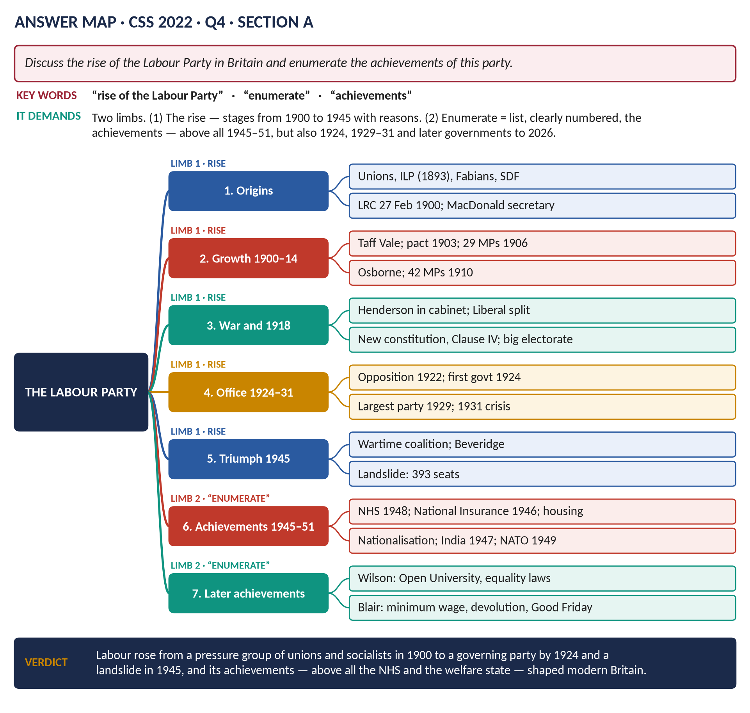
Figure 2 · The answer map for CSS 2022 · Q4 · Section A: every branch is one heading of the answer below.
DECODING THE QUESTION
Two limbs. (1) "Discuss the rise of the Labour Party" — how and why it grew from its foundation (1900) to power (1924, and above all 1945). (2) "Enumerate the achievements of this party" — "enumerate" means list them one by one, clearly numbered. The achievements come mainly from its governments — especially 1945–51 — but a complete answer also mentions later Labour governments down to 2024.

The model answer

Introduction
The Labour Party was founded in 1900 as the Labour Representation Committee, an alliance of trade unions and socialist societies to put working men into Parliament. Within 24 years it had formed a government, and in 1945 it won a landslide that allowed it to build the welfare state. Its rise was driven by the growth of the unions, the extension of the vote, the decline of the Liberals and its own organisation; its achievements — above all the National Health Service — shaped modern Britain.
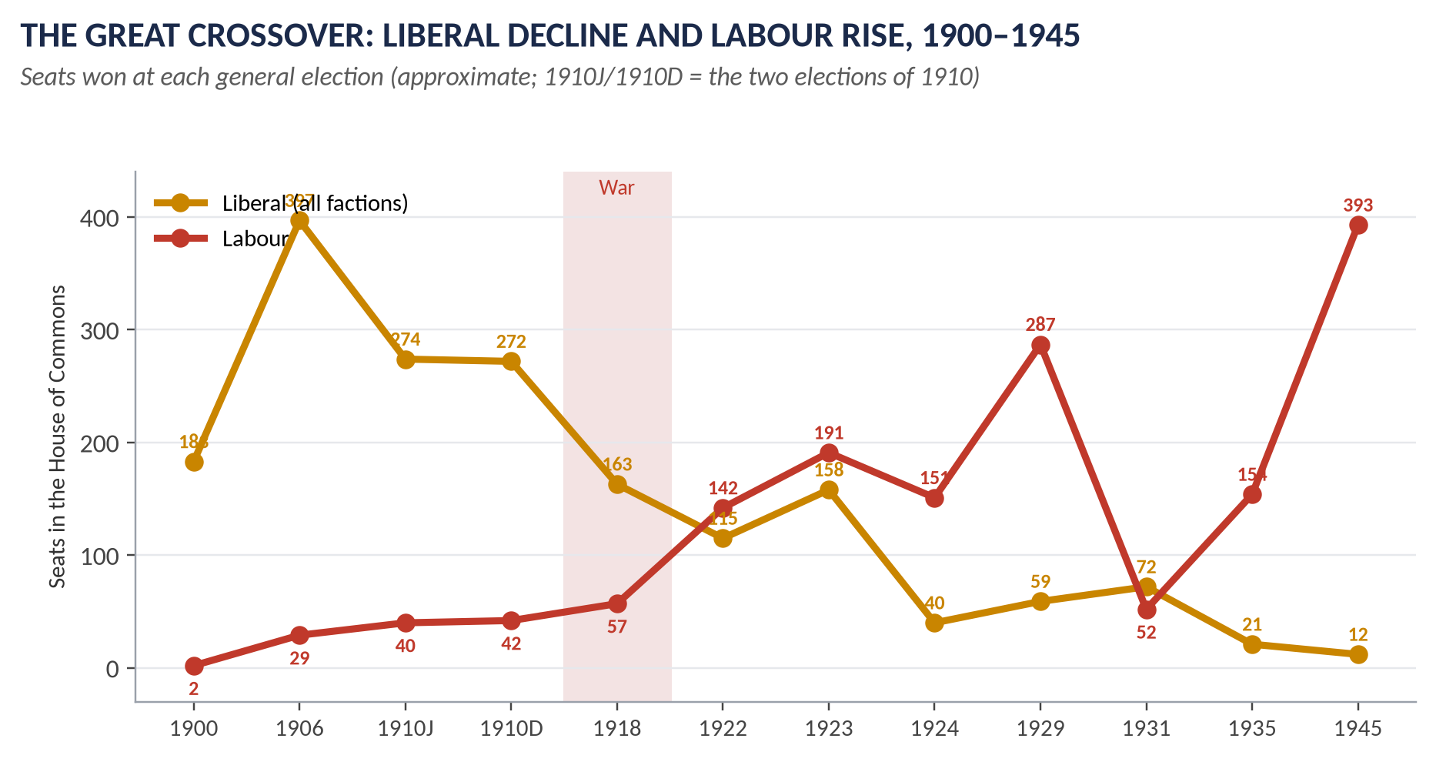
Figure 3 · The great crossover: Liberal decline and Labour rise, 1900–1945.

Limb 1 · The rise of the Labour Party

(1) Origins (before 1900)
- Trade unions: "New Unionism" among the unskilled (the Dock Strike, 1889); about 2 million members by 1900.
- Socialist societies: the Social Democratic Federation (1881), the Fabian Society (1884), the Independent Labour Party (1893) of Keir Hardie, the first independent Labour MP (1892).
- Why a new party: the Liberal Party rarely chose working men as candidates and would not support socialist ideas.

(2) The Labour Representation Committee (1900)
Founded on 27 February 1900 in London; secretary Ramsay MacDonald; aim — a distinct Labour group in Parliament. It won 2 seats in 1900.

(3) The Edwardian breakthrough (1901–1914)
- Taff Vale (1901) drove the unions to support the LRC.
- The Gladstone–MacDonald pact (1903) gave it a clear run in about 30 seats.
- 1906: 29 MPs; renamed the Labour Party; the Trade Disputes Act reversed Taff Vale.
- 1909: the Osborne judgment (no union money for politics), reversed by the Trade Union Act (1913).
- 1910: 42 MPs; 1911: MPs paid.

(4) The First World War (1914–1918)
- Labour supported the war (MacDonald resigned as leader in protest; Arthur Henderson replaced him).
- Henderson joined the coalition (1915) and the war cabinet (1916–17): Labour gained experience and respectability.
- Union membership doubled to about 8 million.
- The 1918 constitution (Henderson and Sidney Webb): local parties with individual members; Clause IV (common ownership of industry).
- The Representation of the People Act (1918) gave the vote to all men over 21 — millions of new working-class voters.
- Meanwhile the Liberals split (Asquith v Lloyd George).

(5) The party of opposition and government (1918–1931)
- 1918: 57 seats. 1922: 142 — the official opposition.
- 1924: the first Labour government (January–November), a minority under MacDonald; it proved Labour could govern; the Wheatley Housing Act. It fell after the Campbell case, and the forged Zinoviev letter helped defeat it.
- 1929: 287 seats — the largest party; the second Labour government.
- 1931: the financial crisis split the cabinet; MacDonald formed a National Government and was expelled; Labour fell to 52 seats.

(6) Recovery and triumph (1931–1945)
- Clement Attlee became leader in 1935.
- The wartime coalition (1940–45): Attlee as Deputy Prime Minister, Ernest Bevin as Minister of Labour — Labour ran the home front.
- The Beveridge Report (1942) promised a welfare state; Labour embraced it.
- The 1945 election: 393 seats, a majority of 146 — the voters rejected a return to the 1930s.
KEY IDEA · Why Labour rose
1. Trade unions — money, members and votes. 2. The franchise — 1918 gave the vote to working men. 3. Liberal decline — the war split the Liberals. 4. Organisation — the 1918 constitution. 5. Class politics — Labour as the party of the working class. 6. The Second World War — Labour's competence in the coalition and the promise of Beveridge.

Limb 2 · The achievements of the Labour Party

(7) Before 1945
1. The Trade Disputes Act (1906, under Labour pressure) — unions protected.
2. Payment of MPs (1911) — working men could enter Parliament.
3. Pressure for the Liberal reforms — school meals, pensions, National Insurance.
4. The first Labour government (1924): Wheatley's Housing Act — about half a million council houses for rent; recognition of the USSR; showed that Labour could govern responsibly.
5. The second Labour government (1929–31): the Coal Mines Act (1930); the Housing Act (1930, slum clearance).

(8) The Attlee government (1945–1951) — the greatest achievements
1. The National Health Service (5 July 1948, Aneurin Bevan) — free medical, hospital, dental and eye care for everyone.
2. The National Insurance Act (1946) — pensions, sickness, unemployment, maternity and widows' benefits for all — "from the cradle to the grave".
3. The National Assistance Act (1948) — a safety net; the end of the old Poor Law.
4. Family allowances (1945–46) for second and later children.
5. Nationalisation: the Bank of England (1946), coal (1947), railways, canals and road haulage (1947–48), electricity (1948), gas (1949), iron and steel (1951).
6. Housing: over a million homes; the New Towns Act (1946) — Stevenage, Harlow and others.
7. Education: the 1944 Act put into effect; school-leaving age raised to 15 (1947).
8. Full employment maintained after the war.
9. Independence for India and Pakistan (1947), Burma and Ceylon (1948) — the beginning of decolonisation.
10. Foreign policy: a founding member of NATO (1949); the Marshall Plan; Bevin's leadership of Western Europe.

(9) Later Labour governments
11. Wilson (1964–70, 1974–76): the Open University (1969); abolition of the death penalty (1965, 1969); reforms on divorce, abortion and homosexuality; the Race Relations Acts (1965, 1968); the Equal Pay Act (1970); comprehensive schools.
12. Callaghan (1976–79).
13. Blair (1997–2007): the national minimum wage (1999); Bank of England independence (1997); devolution — the Scottish Parliament and Welsh Assembly (1999); the Good Friday Agreement (1998); the Human Rights Act (1998); civil partnerships (2004).
14. Brown (2007–10): the response to the 2008 financial crisis; the Climate Change Act (2008).
15. Starmer (from 2024): a landslide of 411 seats on 4 July 2024.
VERDICT · Conclusion
The Labour Party rose from a small alliance of unions and socialists in 1900 to the official opposition in 1922, government in 1924 and a landslide in 1945 — driven by the unions, the wider franchise, the decline of the Liberals and the experience of two world wars. Its achievements, above all the National Health Service and the welfare state of 1945–51, together with independence for India, the minimum wage and devolution, have shaped the Britain of today.

WHY THIS ANSWER SCORES · Why this answer scores
The rise is traced in clear stages with seat figures and a graph · a key box summarises why Labour rose · the achievements are enumerated — numbered one by one, as the question demands — covering 1924 to 2024 · the verdict links the rise to the achievements.

Answer 3 · The Causes of World War I and Its Social and Economic Effects on Britain
THE QUESTION · CSS 2021 · Q4 · Section A · 20 marks
Provide a detailed account of the causes of World War I and its effects on the social and economic aspects of Britain.

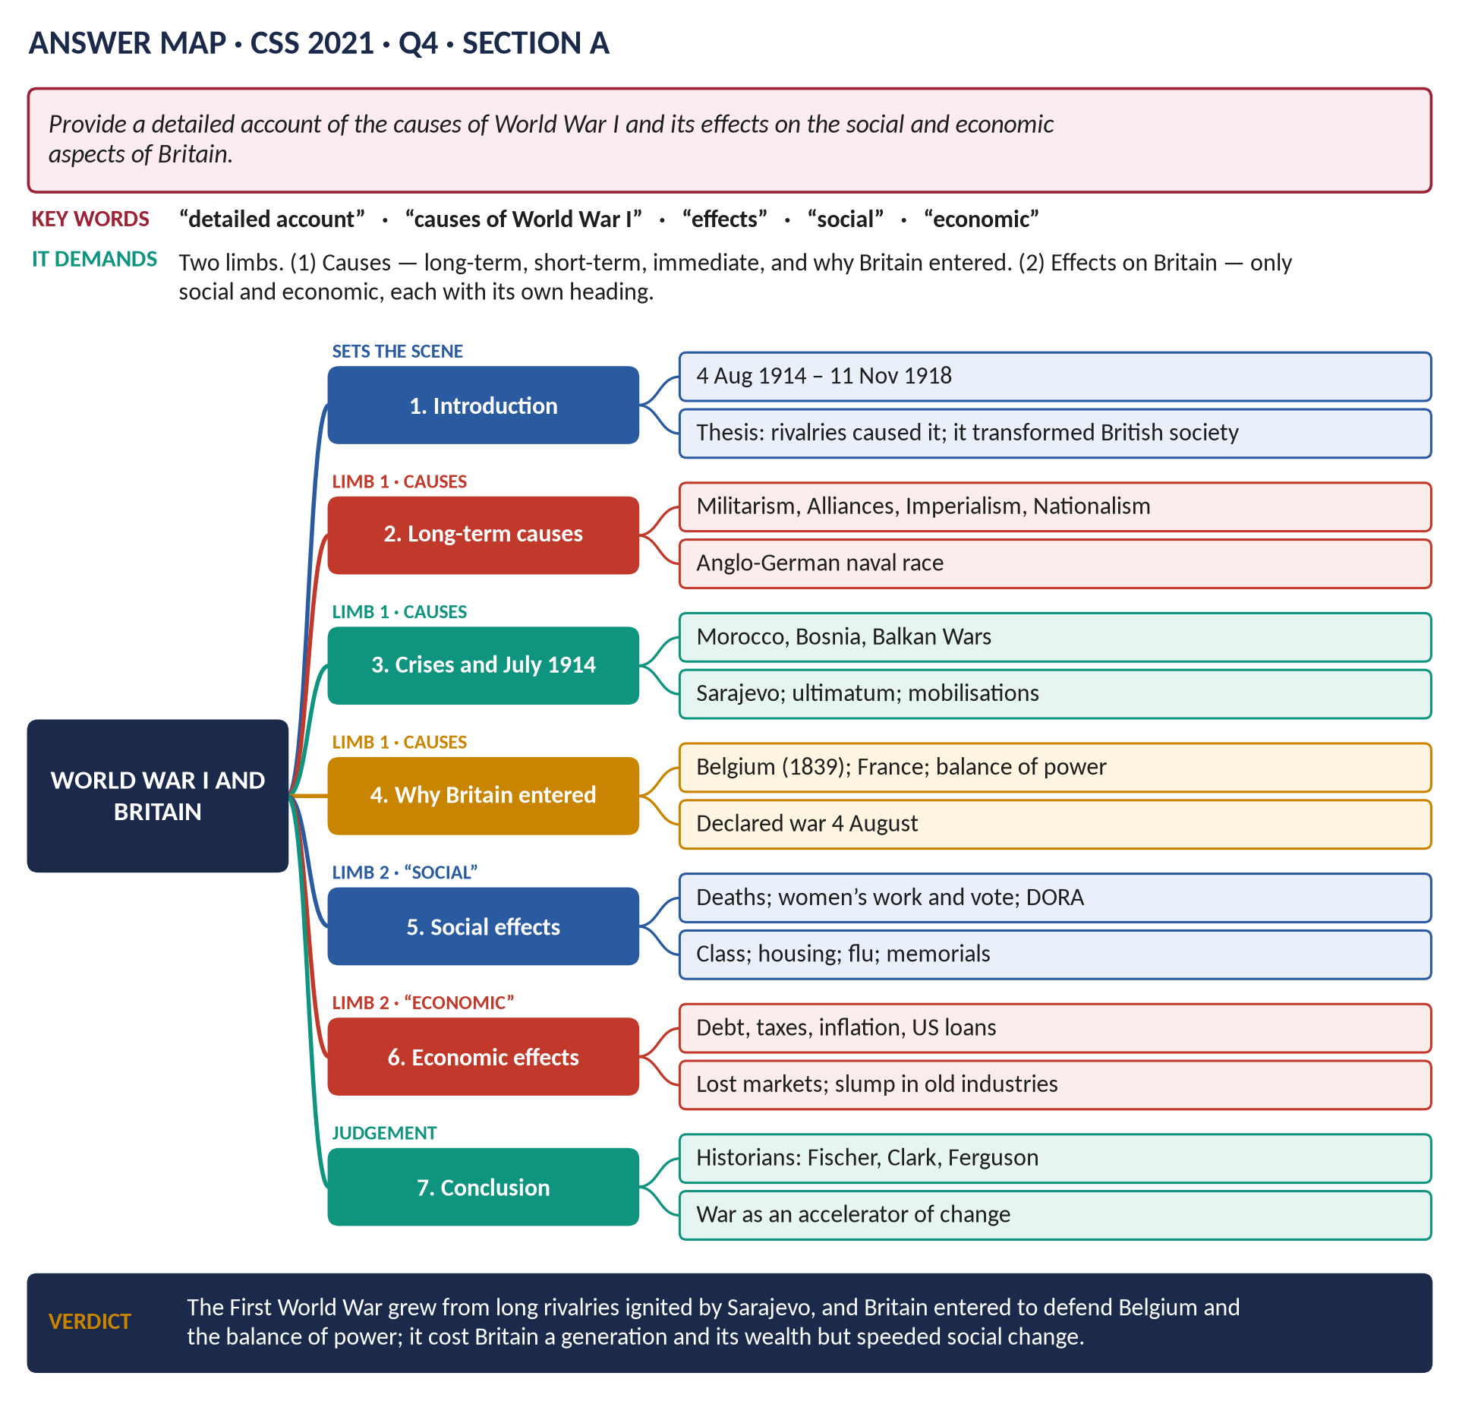
Figure 4 · The answer map for CSS 2021 · Q4 · Section A: every branch is one heading of the answer below.
DECODING THE QUESTION
Two limbs. (1) "Provide a detailed account of the causes of World War I" — long-term causes, the crises, the July Crisis of 1914, and why Britain entered. (2) "Its effects on the social and economic aspects of Britain" — only two kinds of effect are asked: social and economic. Give each its own heading; do not spend time on political or military effects.

The model answer

Introduction
The First World War (1914–1918) was the first "total war" in history. It grew from long-term rivalries among the Great Powers — militarism, alliances, imperialism and nationalism — which a single assassination in Sarajevo in June 1914 turned into a general war within five weeks. Britain entered on 4 August 1914 to defend Belgium and the balance of power. The war transformed British society and economy: it killed about 750,000 British servicemen, changed the position of women and the working class, and turned Britain from the world's creditor into a debtor.
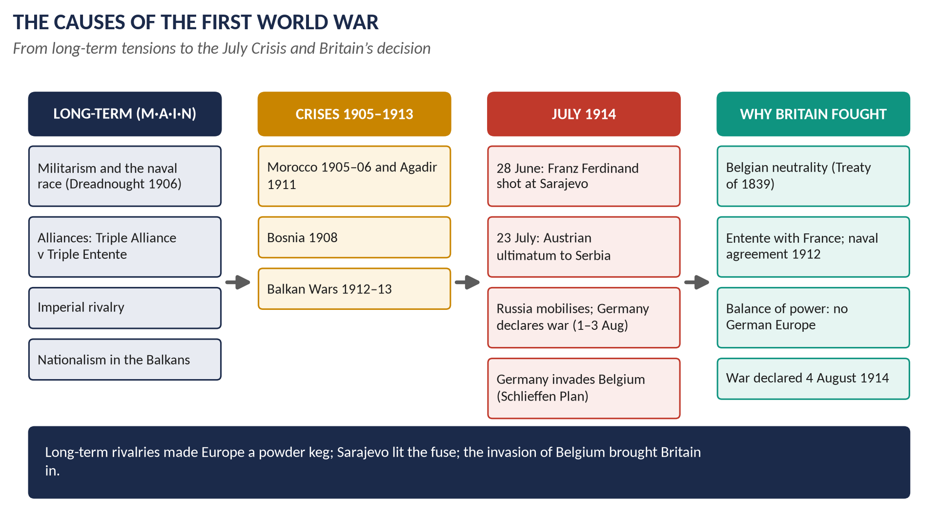
Figure 5 · The causes of the First World War.

Limb 1 · The causes

(1) Militarism
- The great powers built huge conscript armies and detailed war plans. Germany's Schlieffen Plan meant attacking France through neutral Belgium before turning on Russia — so a war with Russia automatically meant war with France and the invasion of Belgium.
- The Anglo-German naval race: Germany's Navy Laws (from 1898) aimed at a fleet to challenge Britain; Britain replied with the Dreadnought (1906) and more battleships ("We want eight and we won't wait", 1909). The race made Germany seem Britain's chief enemy.

(2) Alliances
- The Triple Alliance (1882): Germany, Austria-Hungary, Italy.
- The Triple Entente: France and Russia (1894), Britain and France (1904), Britain and Russia (1907).
- A quarrel between two powers could drag in all the others.

(3) Imperialism
Rivalry for colonies and influence — especially Germany's demand for "a place in the sun" — created suspicion and crises.

(4) Nationalism
- Serbia wanted to unite the South Slavs, including those inside Austria-Hungary; Austria saw Serbia as a deadly threat.
- Russia saw itself as the protector of the Slavs (Pan-Slavism).
- France wanted Alsace-Lorraine back.
- Newspapers stirred popular nationalism everywhere.

(5) The crises (1905–1913)
- Morocco (1905–06 and 1911, Agadir): Germany tried to break the Entente — and strengthened it.
- Bosnia (1908): Austria annexed it; Russia was humiliated and resolved never to back down again.
- The Balkan Wars (1912–13): Serbia grew stronger; Austria grew more fearful.

(6) The July Crisis (1914)
1. 28 June: Archduke Franz Ferdinand was assassinated in Sarajevo by Gavrilo Princip, a Bosnian Serb.
2. 5–6 July: Germany's "blank cheque" of support to Austria.
3. 23 July: Austria's harsh ultimatum to Serbia.
4. 28 July: Austria declared war on Serbia.
5. 30 July: Russia mobilised.
6. 1 and 3 August: Germany declared war on Russia and France.
7. 4 August: Germany invaded Belgium; Britain declared war.

(7) Why Britain entered
1. Belgium: Britain had guaranteed Belgian neutrality in the Treaty of London (1839). Germany's chancellor dismissed it as "a scrap of paper"; its violation united British opinion.
2. France: secret military talks (from 1906) and the naval agreement of 1912 created a moral obligation.
3. The balance of power: a German-dominated Europe, with Germany on the Channel coast, would threaten Britain's security.
4. The German navy: the naval race had made Germany the enemy.
KEY IDEA · Who was responsible? — historians
Fritz Fischer (1961): Germany deliberately sought war. Christopher Clark (The Sleepwalkers, 2012): all the powers shared responsibility. Niall Ferguson (1998): Britain's entry was a mistake that turned a European war into a world war.

Limb 2 · The effects on Britain
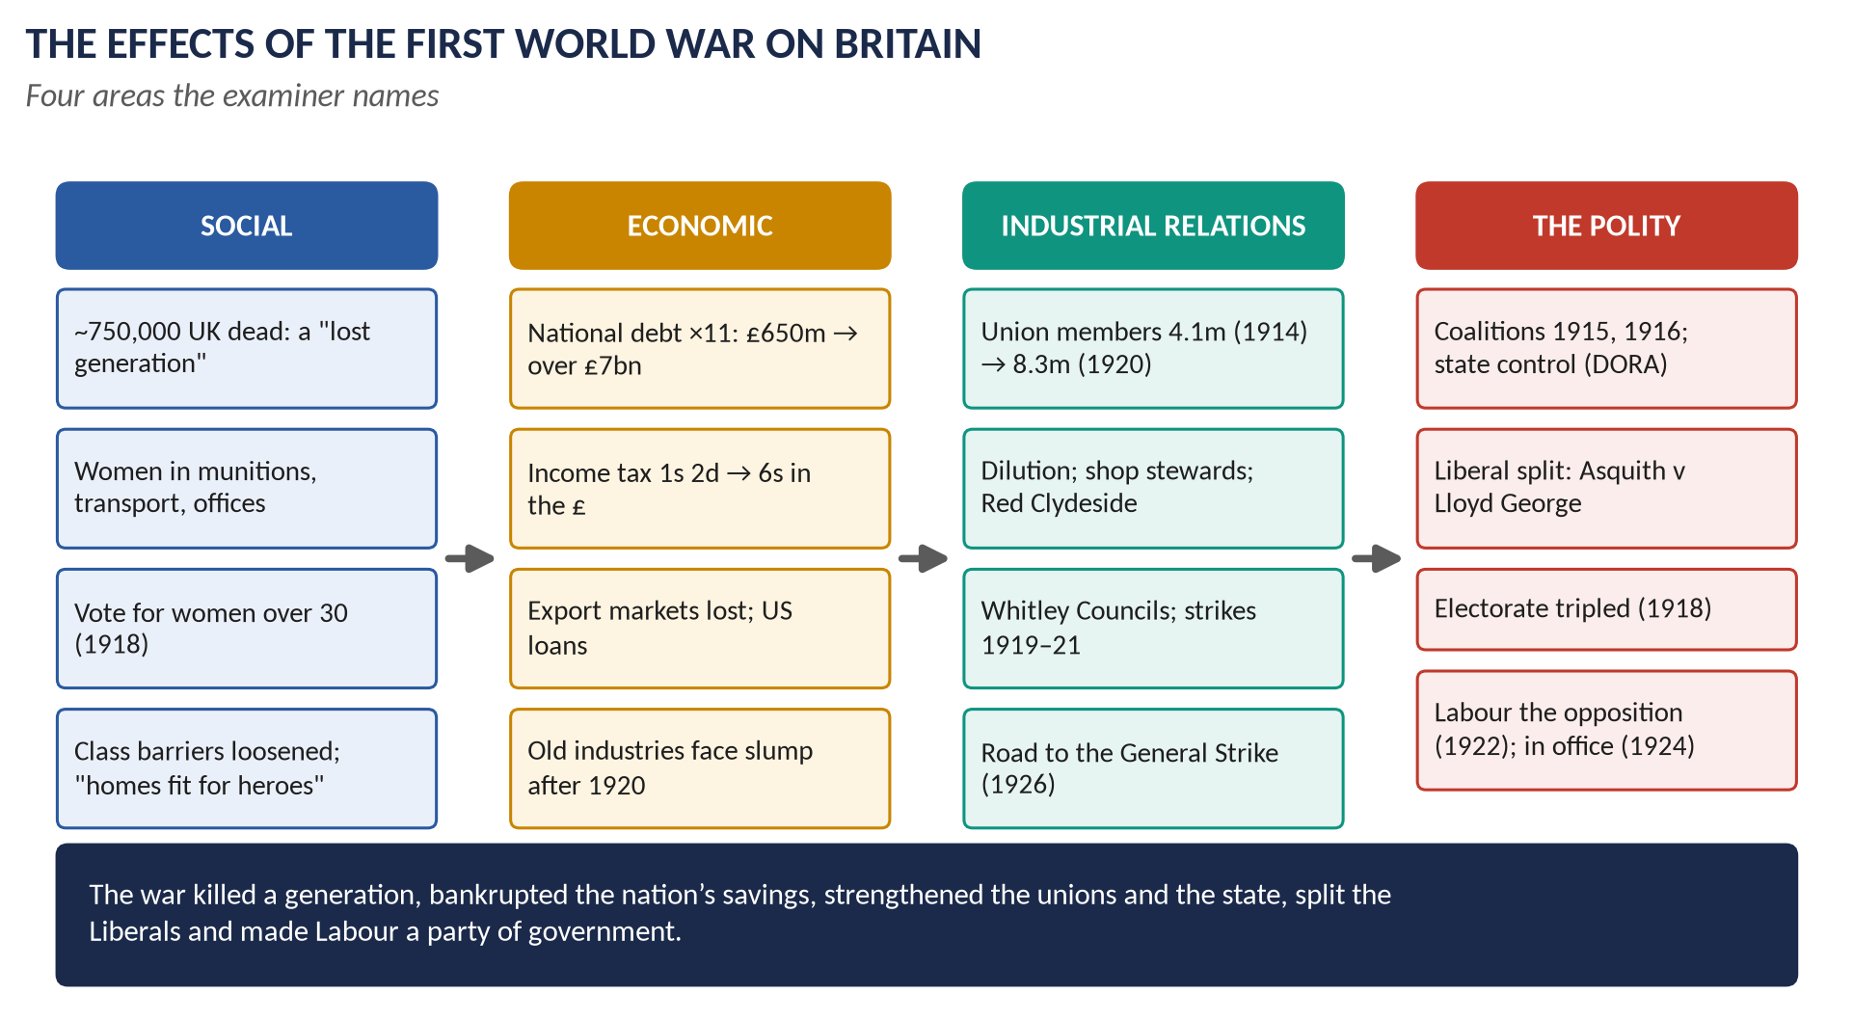
Figure 6 · The effects of the First World War on Britain.

(8) Social effects
1. The human cost: about 750,000 UK servicemen killed and 1.6 million wounded; the "lost generation" of young men; widows, orphans and a generation of women who never married; shell shock. The Spanish flu (1918–19) killed about 228,000 more.
2. Women: about 1.5 million more women entered paid work — munitions (about 950,000 "munitionettes"), transport, offices, farms (the Land Army) and the women's services. They won the vote (over 30) in 1918 and access to the professions (1919). Yet most returned to the home after the war.
3. Class: the aristocracy lost sons and wealth (death duties; about a quarter of England's land sold, 1918–21); the officer class opened to the middle classes; men of all classes shared the trenches; deference declined.
4. Living standards: full employment and higher wages for many workers; rationing (1918) improved the diet of the poorest.
5. The state and daily life: DORA (1914) brought censorship, pub opening hours, British Summer Time; conscription (1916); the state entered daily life as never before.
6. Housing and welfare: "homes fit for heroes" — the Addison Act (1919) began mass council housing; the Fisher Education Act (1918) raised the school-leaving age to 14; unemployment insurance extended (1920).
7. Culture and memory: the war poets (Owen, Sassoon); disillusion; the Cenotaph, the Unknown Warrior (1920), the poppy (1921).

(9) Economic effects
1. Debt: the national debt rose about eleven times, from about £650 million (1914) to over £7 billion (1919).
2. Taxation: the standard rate of income tax rose from 1s 2d to 6s in the pound.
3. Foreign investments: about a quarter sold; Britain borrowed from the USA and became a debtor; New York began to overtake London as the financial centre.
4. Lost markets: the USA and Japan captured Britain's export markets for cotton, coal and ships.
5. Inflation: prices roughly doubled.
6. Shipping: about 7.7 million tons of merchant shipping sunk.
7. Old and new industries: coal, cotton, shipbuilding and steel boomed in the war but slumped after 1920, leaving over a million unemployed throughout the interwar years; new industries (motor vehicles, aircraft, chemicals, electrical goods) grew, and mass production spread.
8. State control: the government ran railways, mines, shipping and food supply — showing what planning could do.
VERDICT · Conclusion
The First World War was caused by the long-term rivalries of militarism, alliances, imperialism and nationalism, sharpened by a decade of crises and set alight by the Sarajevo assassination; Britain joined when Germany invaded Belgium and threatened the balance of power. Socially, the war killed a generation, advanced the position of women and loosened class barriers; economically, it made Britain a debtor, destroyed export markets and left its old industries in lasting decline. Britain won the war but was permanently changed by it.

WHY THIS ANSWER SCORES · Why this answer scores
The causes are detailed in layers — long-term (M·A·I·N), crises, the July Crisis day by day, and Britain's reasons — with a historians' box · the effects are limited to social and economic, exactly as asked, each with numbered, quantified points · a clear verdict.

Answer 4 · Kipling's Two Divisions: Was British Policy in the First World War Justified?
THE QUESTION · CSS 2023 · Q5 · Section A · 20 marks
According to Rudyard Kipling, 'however the world pretends to divide itself, there are only two divisions in the world today — human beings and Germans.' In the light of this statement, was British policy in the First World War justified or not? Comment.

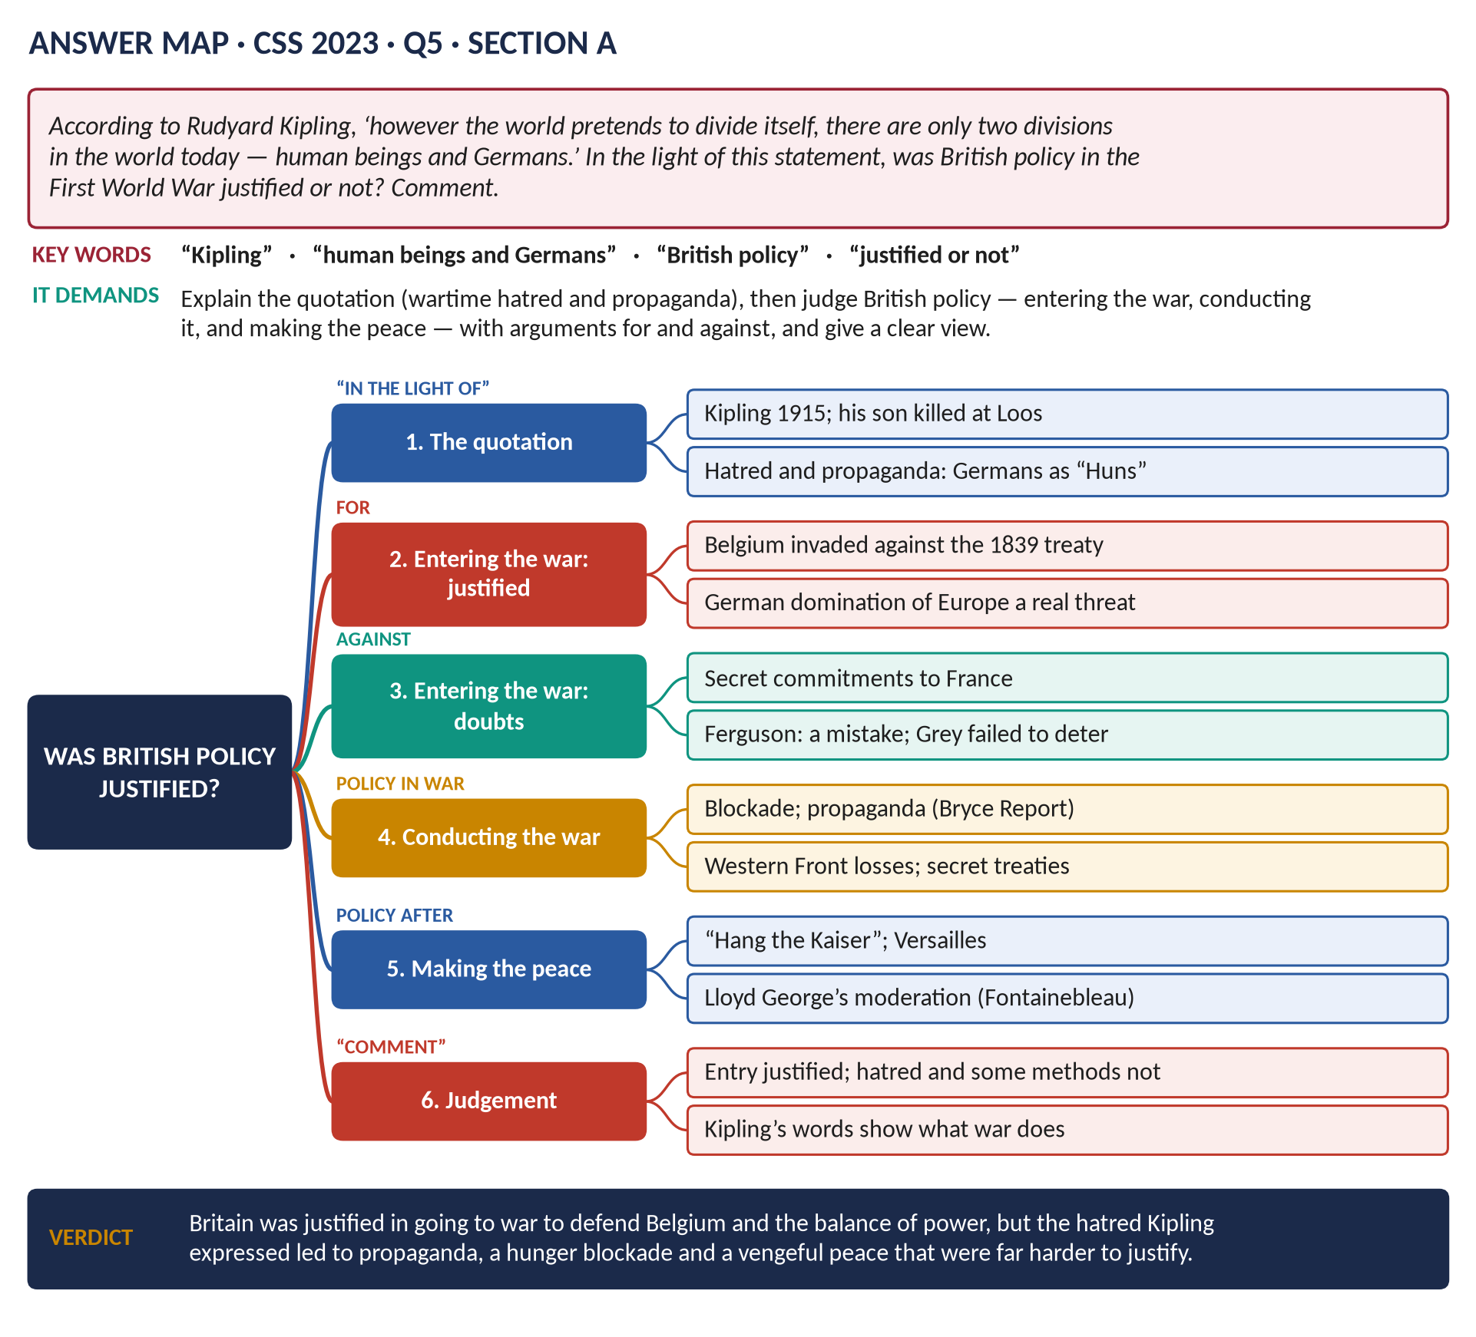
Figure 7 · The answer map for CSS 2023 · Q5 · Section A: every branch is one heading of the answer below.
DECODING THE QUESTION
The quotation: Rudyard Kipling (the famous poet of empire) said in wartime that "however the world pretends to divide itself, there are only two divisions in the world today — human beings and Germans." It expresses the hatred of Germany that swept Britain during the war. "In the light of this statement, was British policy in the First World War justified or not? Comment." So: (1) explain the quotation and the feelings behind it; (2) judge British policy — going to war, conducting it, and making the peace — with arguments for and against; (3) give your judgement clearly.

The model answer

Introduction
Rudyard Kipling, the poet of the British Empire, lost his only son John at the Battle of Loos in September 1915. His bitter words — that there were only "human beings and Germans" in the world — show how deeply the war turned British opinion against Germany, treating Germans as less than human. Was British policy in the war justified? This answer argues that Britain's decision to go to war in 1914 was justified, to defend Belgium and prevent German domination of Europe; but that the hatred Kipling expressed led to some policies in the conduct of the war and the making of the peace that were much harder to justify.

The quotation

(1) What Kipling meant
- Germany was seen as the aggressor that had invaded neutral Belgium and committed atrocities against civilians.
- Germans were portrayed as "Huns" — barbarians — in newspapers and posters.
- The quotation reflects wartime propaganda and personal grief: millions of British families had lost sons.

(2) How widespread the feeling was
- Anti-German riots after the sinking of the liner Lusitania (May 1915; about 1,200 dead).
- German shops attacked; German-born residents interned; dachshunds kicked in the street.
- The royal family changed its German name to Windsor (1917).
- The Bryce Report (1915) on German atrocities in Belgium — partly true, partly exaggerated.

Was British policy justified? — the case for

(3) Going to war was justified
1. Belgium: Germany invaded a neutral country whose neutrality Britain, Prussia and others had guaranteed in 1839. Britain kept its word.
2. German aggression: Germany gave Austria a "blank cheque", declared war on Russia and France, and followed a plan (Schlieffen) that required invading Belgium. Fritz Fischer showed that Germany had far-reaching war aims (the September Programme, 1914) to dominate Europe.
3. Self-defence: a German victory would have put the Channel ports and the continent under German control — a mortal threat to Britain.
4. Obligations to France: the Entente and the naval agreement of 1912 made standing aside dishonourable.
5. Real German brutality: the execution of about 6,500 Belgian and French civilians in 1914; the burning of Louvain; the execution of the British nurse Edith Cavell (1915); unrestricted submarine warfare; the first use of poison gas (1915); Zeppelin raids on British cities.

(4) Some conduct was justified
- The naval blockade was a legitimate weapon of war under the rules of the time.
- Britain fought alongside its allies to the end and helped defeat Germany in 1918.

Was British policy justified? — the case against

(5) Doubts about going to war
1. Secret commitments: the military talks with France were kept secret from Parliament and much of the cabinet; Grey never made Britain's position clear to Germany, which might have deterred it.
2. Niall Ferguson (The Pity of War, 1998) argues Britain's entry was a mistake: it turned a continental war into a world war and cost Britain its wealth.
3. Christopher Clark argues all the powers, not only Germany, stumbled into war.

(6) The conduct of the war
1. Propaganda and hatred: the Bryce Report and the press encouraged exactly the hatred Kipling expressed.
2. The hunger blockade: it continued after the Armistice until July 1919; hundreds of thousands of German civilians died of hunger-related causes.
3. The Western Front: generals such as Haig sent millions into attacks with enormous losses (the Somme, Passchendaele) — "lions led by donkeys", though historians now debate this.
4. Secret and contradictory promises: the Treaty of London (1915) with Italy; the Sykes–Picot Agreement (1916) dividing Arab lands; the McMahon–Hussein promises of Arab independence; the Balfour Declaration (1917) promising a Jewish national home — promises that could not all be kept.
5. Conscientious objectors were imprisoned and badly treated.

(7) Making the peace
1. The 1918 election: candidates promised to "hang the Kaiser" and "squeeze Germany until the pips squeak".
2. Versailles (1919): the war guilt clause, heavy reparations and the loss of territory created deep German resentment, which Hitler later exploited.
3. But: Lloyd George himself argued for moderation in the Fontainebleau Memorandum (March 1919), and Britain was less harsh than France.
Area of policy | Justified? | Why
Entering the war | Largely yes | Belgium; German aggression; balance of power
Conduct | Mixed | A just war, but hatred, propaganda, the hunger blockade, costly generalship, secret treaties
Peace | Partly | Moderation by Lloyd George, but a vengeful election and a humiliating treaty

(8) What Kipling's words teach
Kipling's statement shows how a just cause can be corrupted by hatred. Seeing the enemy as less than human made it easier to accept huge casualties, to starve civilians, and to impose a vengeful peace. Kipling himself later wrote, for the war graves, "If any question why we died, / Tell them, because our fathers lied" — a sign of the bitterness many felt afterwards.
VERDICT · Comment
British policy in the First World War was justified in its central purpose: Britain went to war to honour its guarantee to Belgium and to stop German domination of Europe, and German aggression and brutality were real. But the spirit of Kipling's words — that Germans were not human beings — led Britain into propaganda, a hunger blockade and a vengeful peace that are much harder to justify, and that helped prepare the ground for a second war. The cause was just; much of the policy that the hatred produced was not.

WHY THIS ANSWER SCORES · Why this answer scores
It explains the quotation (who, when, why, the grief behind it) · it judges three areas of policy — entry, conduct, peace — for and against · it uses historians (Fischer, Ferguson, Clark) and specific evidence (Lusitania, Bryce, Sykes–Picot, Fontainebleau) · a summary table · a clear, reasoned comment that ties back to Kipling.

Answer 5 · The War, British Society and Politics — the Liberal Fall and the Labour Rise
THE QUESTION · CSS 2026 · Q5 · Section A · 20 marks
Critically evaluate the effects of World War I on British social structure, industrial relations, and the polity, highlighting the ways in which the war accelerated the decline of the Liberal Party and paved the way for Labour's rise to power.

Figure 8 · The answer map for CSS 2026 · Q5 · Section A: every branch is one heading of the answer below.
DECODING THE QUESTION
A demanding question with four parts. (1)–(3): the effects of the war on three named areas — social structure (the classes and groups that make up society), industrial relations (relations between employers, workers, unions and the state), and the polity (the political system: government, Parliament, parties, voters). (4) The key argument: how the war accelerated ("speeded up") the decline of the Liberal Party and paved the way for Labour's rise to power. "Critically evaluate" = weigh the war against other causes (pre-war trends, the 1918 franchise) and judge.

The model answer

Introduction
The First World War (1914–18) was a "total war": it demanded the whole nation's manpower, industry and money. It therefore changed Britain far more than any earlier war — its social structure, its industrial relations and its polity. Among its most important political results was the downfall of the Liberal Party, which had governed with a huge majority in 1906, and the rise of Labour, which formed its first government only six years after the war. This answer argues that the war was not the only cause of this great change, but it was the decisive accelerator: it split the Liberals, strengthened organised labour and tripled the electorate.
Figure 9 · The effects of the war on Britain.

(1) Effects on social structure
1. The upper classes weakened: a high proportion of young aristocrats and public-school officers were killed (about one in five Etonians who served died); death duties and taxes forced the sale of great estates — about a quarter of England's land changed hands in 1918–21.
2. The middle classes filled the expanding officer corps, civil service and new industries.
3. The working class gained from full employment, higher wages and the rationing of food; its confidence and organisation grew.
4. Women: about 1.5 million more in paid work, especially munitions (about 950,000); the vote at 30 (1918); the Sex Disqualification (Removal) Act (1919) — though most women returned to the home after 1918.
5. Deference declined: men of all classes had shared the trenches; people were less willing to accept the authority of their "betters".
6. The lost generation: about 750,000 UK dead, mostly young — a demographic and emotional wound.

(2) Effects on industrial relations
1. Union growth: membership rose from 4.1 million (1914) to 8.3 million (1920).
2. Partnership with the state: in the Treasury Agreement (1915) union leaders accepted dilution (unskilled workers, including women, doing skilled work) and no strikes, in return for consultation and limits on profits. Union leaders sat on government committees.
3. Shop stewards and militancy: local workplace leaders challenged both employers and union officials — Red Clydeside in Glasgow (rent strikes 1915; the 40-hours strike of 1919, when tanks were sent to George Square).
4. Whitley Councils (1917): joint councils of employers and workers in many industries.
5. State control of mines and railways raised hopes of nationalisation — the Sankey Commission (1919) recommended it for the mines, but Lloyd George refused.
6. Post-war conflict: a record wave of strikes in 1919 (even the police); Black Friday (April 1921); the road to the General Strike (1926).

(3) Effects on the polity
1. A bigger, stronger state: DORA, conscription, control of industry and food; government spending rose to over half the national income.
2. Coalition government: Asquith's coalition (May 1915) and Lloyd George's (December 1916); a small War Cabinet — a more powerful Prime Minister.
3. Democracy: the Representation of the People Act (1918) gave the vote to all men over 21 and women over 30 — the electorate rose from about 7.7 million to about 21.4 million. The new voters were mostly working-class men and women.
4. The party system: the Liberals split; Labour replaced them as the main party of the left; Sinn Féin swept nationalist Ireland (1918) — Irish MPs left Westminster, which removed the Liberals' old Irish allies.

How the war accelerated the decline of the Liberal Party

(4) The Liberals before 1914 — dying or healthy?
- George Dangerfield (The Strange Death of Liberal England, 1935): Liberal England was already dying before the war, destroyed by the Lords crisis, the suffragettes, the strikes and Ulster.
- P. F. Clarke and Trevor Wilson: the Liberals were healthy in 1914 — New Liberalism and its reforms held working-class votes; Labour was a junior partner with about 40 MPs.
- Most historians now agree that the war was decisive.

(5) The war and Liberal principles
A Liberal government had to fight a total war that contradicted Liberal ideas: conscription (1916) against individual freedom; DORA and censorship against free speech; state control of industry against laissez-faire; the McKenna duties (1915) against free trade. Many Liberals felt their party had lost its soul.

(6) The Liberal split
- May 1915: Asquith had to form a coalition with the Conservatives after the shell crisis.
- December 1916: Lloyd George, backed by the Conservatives, replaced Asquith as Prime Minister. The party divided into two rival groups — Asquith's official Liberals and Lloyd George's coalition Liberals.
- May 1918: the Maurice debate — 98 Liberals voted with Asquith against the government.
- December 1918: the "coupon election": Lloyd George's candidates received a letter of endorsement; Asquith's Liberals won only about 36 seats and Asquith lost his own seat.
- 1922: when the coalition fell, the Liberals were divided and without a cause; reunited in 1923, they were too late.

(7) Trevor Wilson's image
The war was like "a rampant omnibus" (a runaway bus) that ran down the Liberal Party — a party that might otherwise have survived.

How the war paved the way for Labour

(8) Labour gained from the war
1. Experience and respectability: Arthur Henderson sat in the coalition (1915) and the War Cabinet (1916–17); Labour ministers showed they could govern.
2. Unity: unlike the Liberals, Labour survived its wartime disagreements (MacDonald's opposition) without a lasting split.
3. The unions: doubled in size — more members, more money, more votes for Labour.
4. Organisation and programme: the 1918 constitution (Henderson and Sidney Webb) created local parties with individual members across the country and a clear socialist aim (Clause IV) — Labour became a national party, not just a union pressure group.
5. The franchise: the millions of new working-class voters of 1918 were natural Labour supporters.
6. Ideas: state control in the war made nationalisation and planning seem practical.

(9) The results
Election | Liberal seats | Labour seats | Meaning
1910 (Dec) | 272 | 42 | Liberals dominant
1918 | about 163 (split) | 57 | Liberals divided
1922 | about 115 (split) | 142 | Labour the opposition
1924 | 40 | 151 | Labour governed (Jan–Nov 1924)
1929 | 59 | 287 | Labour the largest party

Figure 10 · The great crossover, 1900–1945.

Critical evaluation

(10) Weighing the war against other causes
- Pre-war trends: Labour was growing and the unions were strong before 1914; class-based politics was emerging. The war accelerated these trends rather than creating them.
- The franchise: Ross McKibbin argues that the narrow pre-1918 franchise hid Labour's strength; once all men could vote, class would have favoured Labour anyway. But the 1918 Act itself was a product of the war.
- The Liberal split was a wartime event, and without it the Liberals would have faced the new electorate united and with their reforming record.
- Lloyd George himself remained a powerful figure; the Liberals' 1929 programme (Keynesian public works) showed they still had ideas — but by then Labour had taken their place.
VERDICT · Conclusion
The First World War transformed Britain: it weakened the old upper class and raised the status of women and workers; it doubled the unions and made them partners — and opponents — of the state; and it built a stronger state and a mass democracy. Above all it turned a slow political change into a rapid one. By contradicting Liberal principles, splitting the Liberal leadership and tripling the electorate while strengthening Labour's organisation and unions, the war destroyed the Liberals as a party of government and made Labour the official opposition within four years and the government within six.

WHY THIS ANSWER SCORES · Why this answer scores
Each named area — social structure, industrial relations, polity — has its own section with evidence · the Liberal decline and Labour rise are explained through specific mechanisms (principles, the split, the coupon, the constitution, the franchise) · a seats table and graph give proof · the critical evaluation weighs the war against pre-war trends and the franchise, using Dangerfield, Wilson, Clarke and McKibbin.

Short Note

Lord Kitchener
THE QUESTION · CSS 2022 · Q8(a) · Section B · short note (10 marks)
Write a short note on: Lord Kitchener

Horatio Herbert Kitchener, 1st Earl Kitchener (1850–1916), soldier of the British Empire and Secretary of State for War at the start of the First World War.
- Early career: born in County Kerry, Ireland; Royal Engineers; surveyed Palestine and served in Egypt.
- The Sudan: as Sirdar (commander) of the Egyptian army (1892) he reconquered the Sudan, destroying the Mahdist army at Omdurman (2 September 1898) and avenging Gordon — "Kitchener of Khartoum". He handled the Fashoda confrontation with France (1898) with firmness and tact.
- The Boer War: chief of staff and then commander (1900–02); he defeated Boer guerrillas with blockhouses, farm-burning and concentration camps (in which about 26,000 Boer women and children died), and negotiated Vereeniging (1902).
- India: Commander-in-Chief (1902–09); his struggle for control of the army led to the resignation of the Viceroy Lord Curzon (1905).
- Egypt: Consul-General (effectively ruler), 1911–14.
- Secretary of State for War (from 5 August 1914): almost alone he foresaw a long war of three years or more needing millions of men. His face on the poster "Your Country Needs You" helped raise about 2.5 million volunteers — the "New Armies" or "Kitchener's Army".
- Criticism: he was a poor cabinet colleague who would not delegate; he was blamed for the shell shortage (1915) and lost control of munitions to Lloyd George and of strategy to the General Staff.
- Death: drowned on 5 June 1916 when HMS Hampshire struck a German mine off Orkney, on a mission to Russia.
In one line: the great imperial soldier of late-Victorian Britain, whose foresight and fame created the mass army of 1914–16, though he was ill-suited to the politics of total war.

Answer 6 · British Foreign Policy, 1919–1939
THE QUESTION · CSS 2015 · Q8 · Paper II · 20 marks
Describe and critically analyze the foreign policy of England from 1919 to 1939.

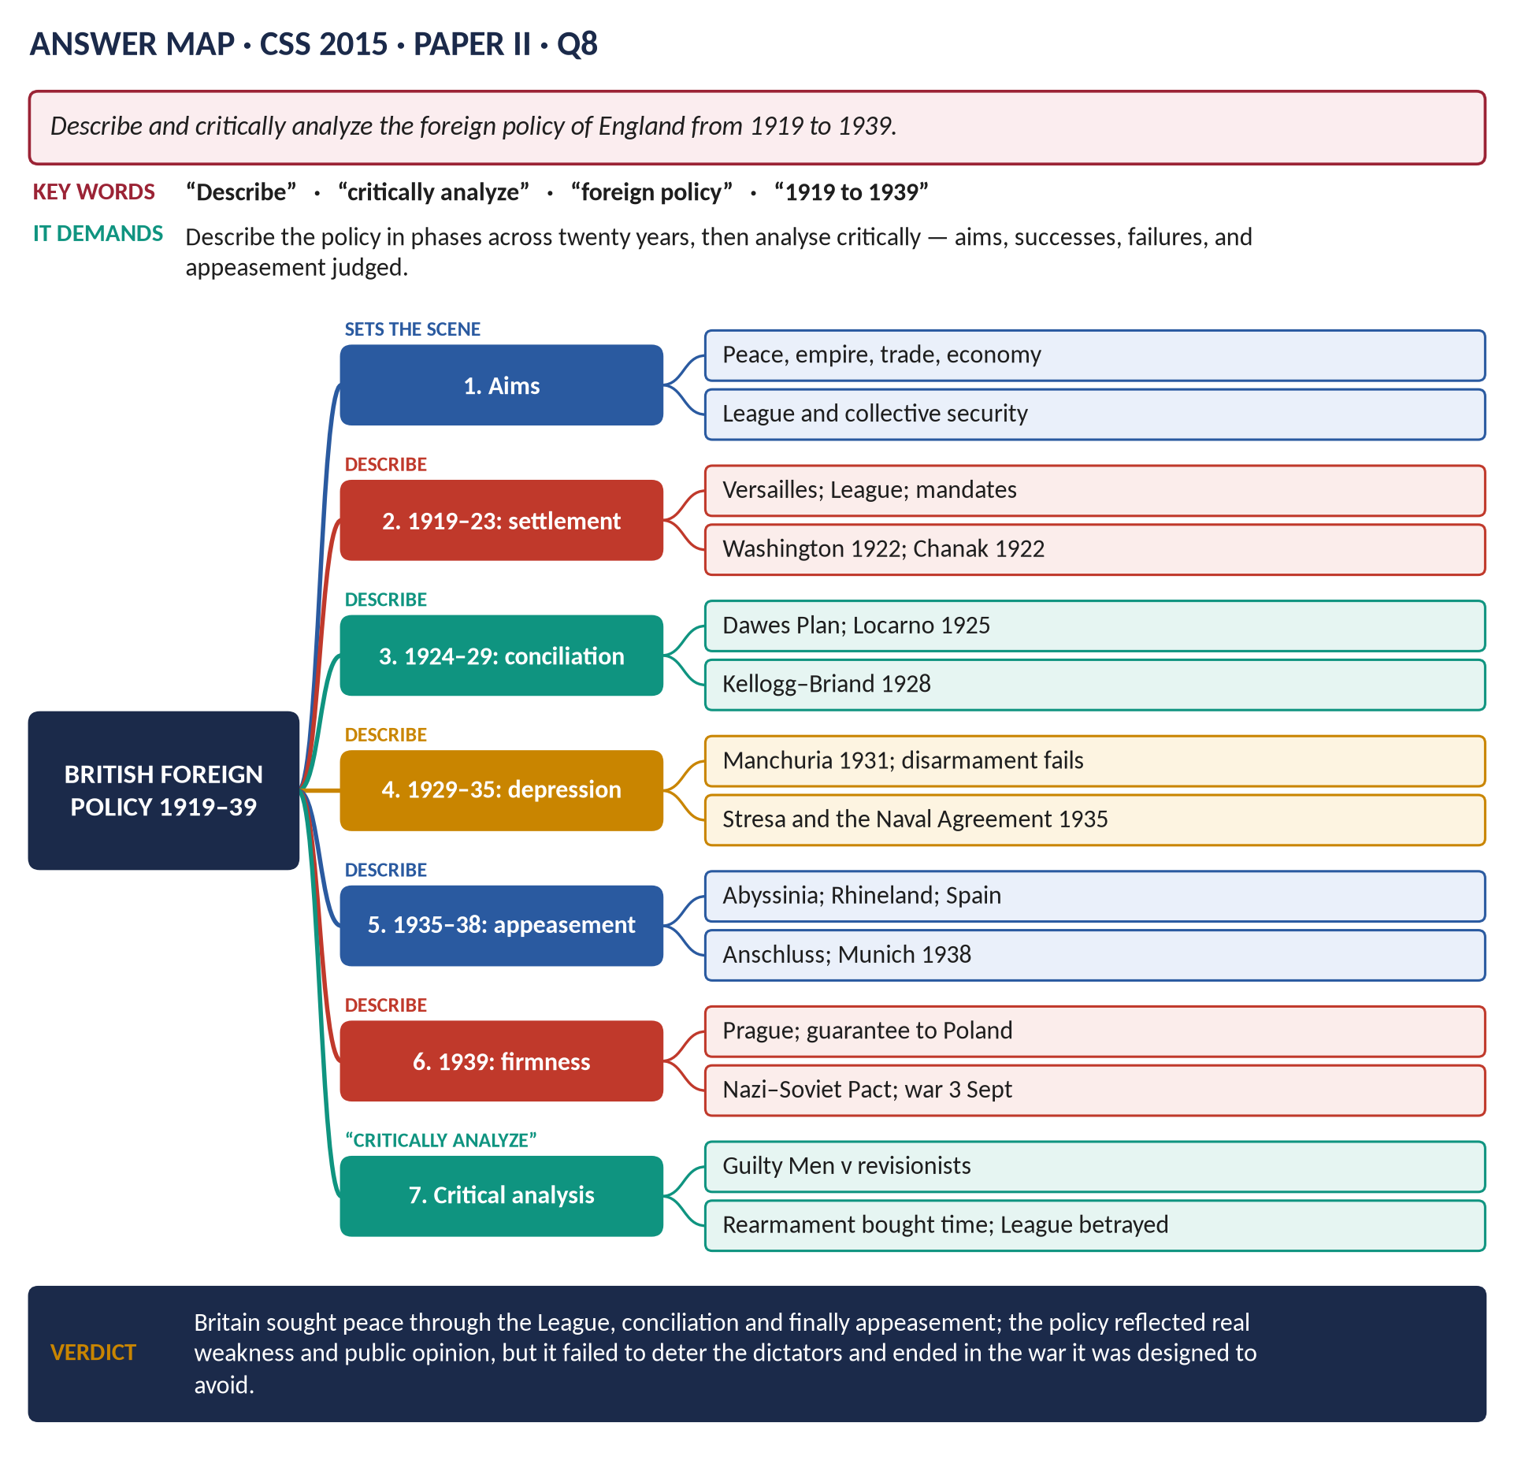
Figure 11 · The answer map for CSS 2015 · Q8 · Paper II: every branch is one heading of the answer below.
DECODING THE QUESTION
"Describe and critically analyze" = first describe the policy across twenty years (best in phases), then analyse critically — its aims, what shaped it, what worked and what failed, and whether it was wise (especially appeasement). Use English policy to mean British policy. Do not write a history of Hitler — keep Britain at the centre.

The model answer

Introduction
Between 1919 and 1939 British foreign policy aimed above all at peace: to secure the empire, revive trade, avoid another catastrophic war and save money. Britain pursued these aims through the peace settlement and the League of Nations (1919–23), conciliation of Germany (1924–29), disarmament and caution during the Depression (1929–35), appeasement of the dictators (1935–38), and finally firmness (1939). The policy reflected real weaknesses and a nation's horror of war, but it failed to deter Germany, Italy and Japan and ended in the war it was meant to prevent.

(1) The aims and the limits
- Aims: peace; the security of the empire and trade routes; economic recovery; economy in defence.
- Limits: huge war debts; declining industries; an over-stretched empire (Ireland, India, Egypt, Palestine); Dominions unwilling to fight in Europe; a public that wanted "never again".
- The Ten Year Rule (1919–1932): the services were told to assume no major war for ten years.

Description — the five phases

(2) Phase 1 · 1919–1923: making the peace
- Versailles (1919): Lloyd George sought a moderate peace between Wilson and Clemenceau; Britain gained the German fleet's destruction and mandates (Palestine, Iraq, Transjordan, Tanganyika).
- The League of Nations (1920): Britain a leading permanent member of the Council.
- The Washington Naval Treaty (1922): battleship ratio 5 : 5 : 3 (Britain : USA : Japan) — Britain accepted naval parity with the USA and ended the Anglo-Japanese Alliance.
- Russia: intervention ended; the Trade Agreement (1921).
- Chanak (1922): Lloyd George's threat of war with Turkey; the Dominions refused help; his coalition fell.

(3) Phase 2 · 1924–1929: conciliation — "the spirit of Locarno"
- MacDonald recognised the USSR and supported the Dawes Plan (1924), which eased reparations with US loans.
- The Locarno Treaties (1925, Austen Chamberlain): Germany, France and Belgium accepted their western borders, which Britain and Italy guaranteed; Germany joined the League (1926). A period of hope.
- The Kellogg–Briand Pact (1928) renounced war; the Young Plan (1929) reduced reparations further.

(4) Phase 3 · 1929–1935: the Depression and the dictators
- The Great Depression made Britain even more cautious and short of money.
- Manchuria (1931): Britain would not act against Japan.
- Disarmament: the World Disarmament Conference (1932–34) failed; Hitler (in power from January 1933) left the conference and the League.
- 1935: Hitler announced conscription; the Stresa Front (April) of Britain, France and Italy protested — then Britain signed the Anglo-German Naval Agreement (June 1935), allowing Germany a fleet 35 per cent of Britain's, without consulting France.

(5) Phase 4 · 1935–1938: appeasement
- Abyssinia (1935–36): Britain backed League sanctions but not oil sanctions; the Hoare–Laval Pact (December 1935) secretly offered Italy much of Abyssinia. The League was discredited and Italy moved towards Germany.
- The Rhineland (March 1936): Hitler remilitarised it; Britain did nothing.
- The Spanish Civil War (1936–39): Britain's non-intervention policy, while Germany and Italy armed Franco.
- Neville Chamberlain (PM from May 1937) made appeasement an active policy — to find and settle Germany's grievances.
- The Anschluss (March 1938): Germany took Austria.
- Czechoslovakia and Munich (September 1938): after meetings at Berchtesgaden and Godesberg, Britain, France, Germany and Italy agreed at Munich (29–30 September) that Germany should take the Sudetenland; Czechoslovakia was not consulted. Chamberlain: "peace for our time". Churchill: "a total and unmitigated defeat".
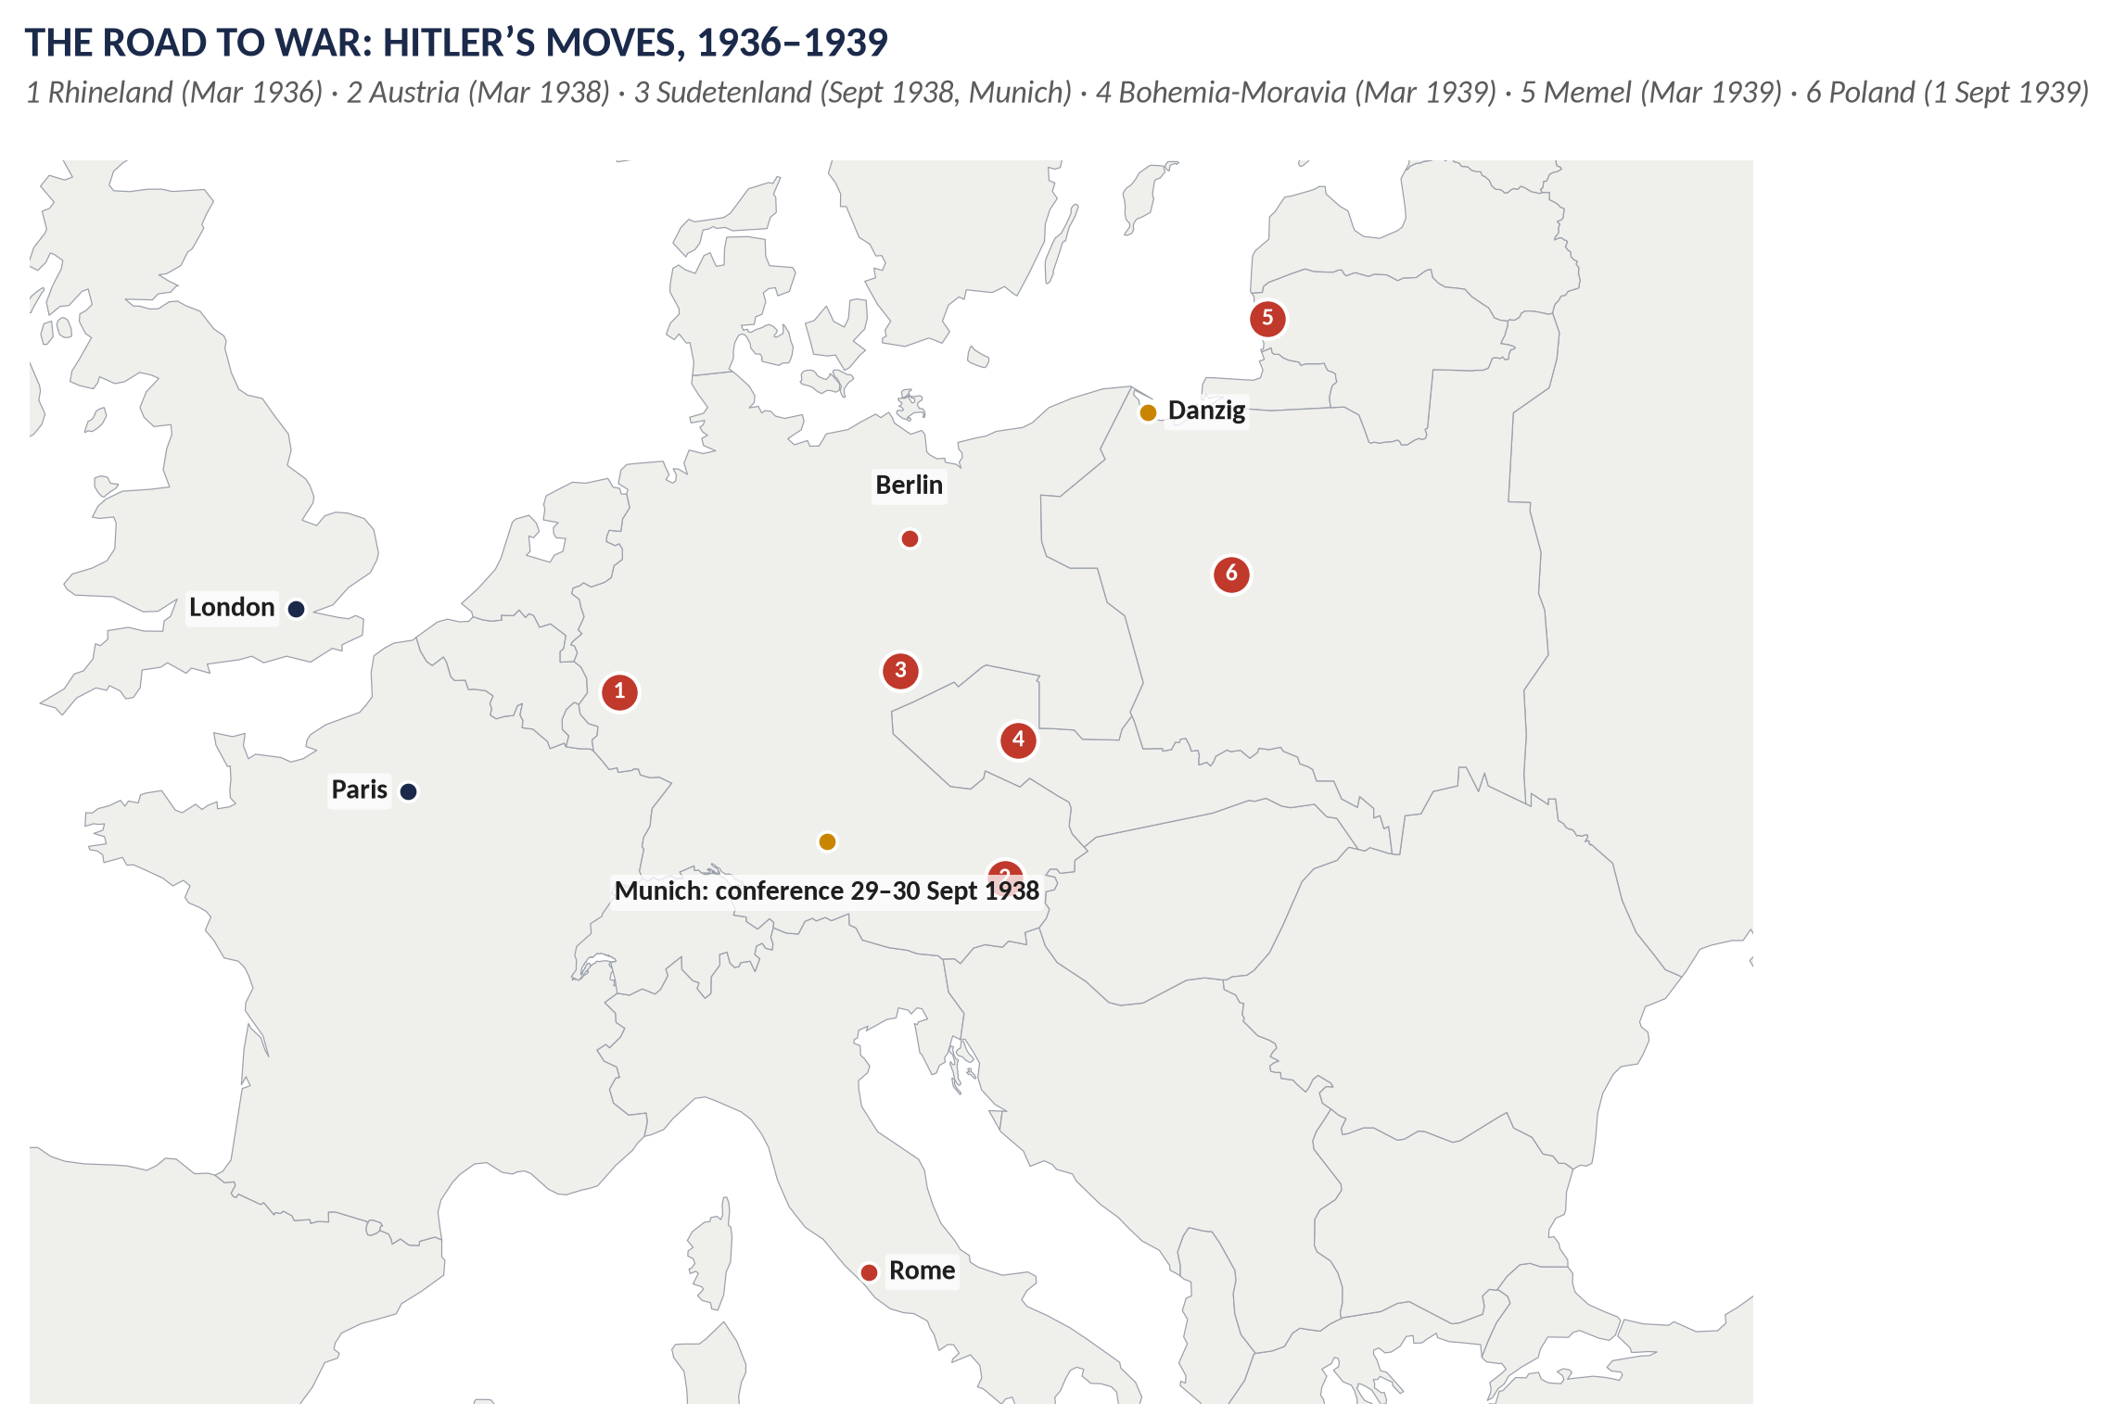
Figure 12 · Hitler's moves, 1936–1939.

(6) Phase 5 · 1939: from appeasement to war
- 15 March 1939: Germany seized Prague — Hitler had broken the Munich promise and taken non-German lands.
- 31 March: Britain guaranteed Poland; then Romania and Greece.
- April: peacetime conscription.
- Half-hearted talks with the USSR failed; the Nazi–Soviet Pact (23 August).
- 1 September: Germany invaded Poland. 3 September 1939: Britain declared war.

(7) Rearmament
The Ten Year Rule was dropped (1932); the RAF expanded from 1934; radar, the Spitfire and Hurricane and "shadow factories" were developed; defence spending roughly quadrupled between 1935 and 1939.

Critical analysis

(8) What shaped the policy
1. Public opinion: the memory of 1914–18; the Peace Ballot (1935) — over 11 million votes for the League; the Oxford Union "King and Country" debate (1933).
2. Guilt over Versailles: Keynes and others had convinced many that Germany had been treated unfairly.
3. Military weakness: the chiefs of staff warned Britain could not fight Germany, Italy and Japan at once.
4. Economy: the Depression and debts; the Treasury feared rearmament would ruin the economy.
5. The Empire and Dominions: they would not support war over Central Europe in 1938.
6. No reliable allies: the USA was isolationist; France was divided; the USSR was distrusted.
7. Anti-communism: some saw Hitler as a barrier against Soviet Russia.

(9) Successes
- The 1920s were a real period of peace and reconciliation (Locarno).
- Rearmament, especially of the RAF and radar, prepared Britain for the Battle of Britain (1940).
- When war came in 1939, Britain and the Dominions entered united, having shown they had tried every path to peace.

(10) Failures
- The League and collective security were abandoned when they were tested (Manchuria, Abyssinia).
- The Naval Agreement (1935) broke the Stresa Front and Versailles.
- Appeasement encouraged Hitler: each success made him bolder; he concluded that Britain would not fight.
- Munich sacrificed Czechoslovakia, with its strong army, fortresses and arms industry (the Škoda works).
- Britain failed to ally with the USSR, which then made its pact with Hitler.

(11) The historians' debate
- *"Cato", Guilty Men* (1940**): Chamberlain and his colleagues were guilty of weakness and folly.
- A. J. P. Taylor (The Origins of the Second World War, 1961): appeasement was understandable; Hitler was an opportunist.
- Revisionists (the 1960s–80s): appeasement was a rational response to Britain's weakness and bought time to rearm.
- R. A. C. Parker (Chamberlain and Appeasement, 1993): Chamberlain had alternatives — a "Grand Alliance" with France and the USSR — and rejected them.
VERDICT · Conclusion
British foreign policy from 1919 to 1939 sought peace through the League, conciliation and, finally, appeasement. It was shaped by real constraints — economic weakness, an over-stretched empire, reluctant Dominions and a public determined never to repeat the slaughter of 1914–18 — and it achieved a decade of hope in the 1920s and time to rearm in the late 1930s. But it abandoned collective security when it was tested, and by appeasing Hitler it convinced him that Britain would not fight, so that the policy designed to prevent war ended in the Second World War.

WHY THIS ANSWER SCORES · Why this answer scores
Description in five clear phases covering the full twenty years, with dates · a section on rearmament · the critical analysis explains what shaped the policy, its successes and failures, and the historians' debate — from Guilty Men to Parker · a map of Hitler's moves · a balanced verdict.

Answer 7 · The League of Nations: Its Work and Its Failure
THE QUESTION · CSS 2020 · Q7 · Section B · 20 marks
What do you know about the League of Nations? Explain the work of the League. What were the causes of its failure?

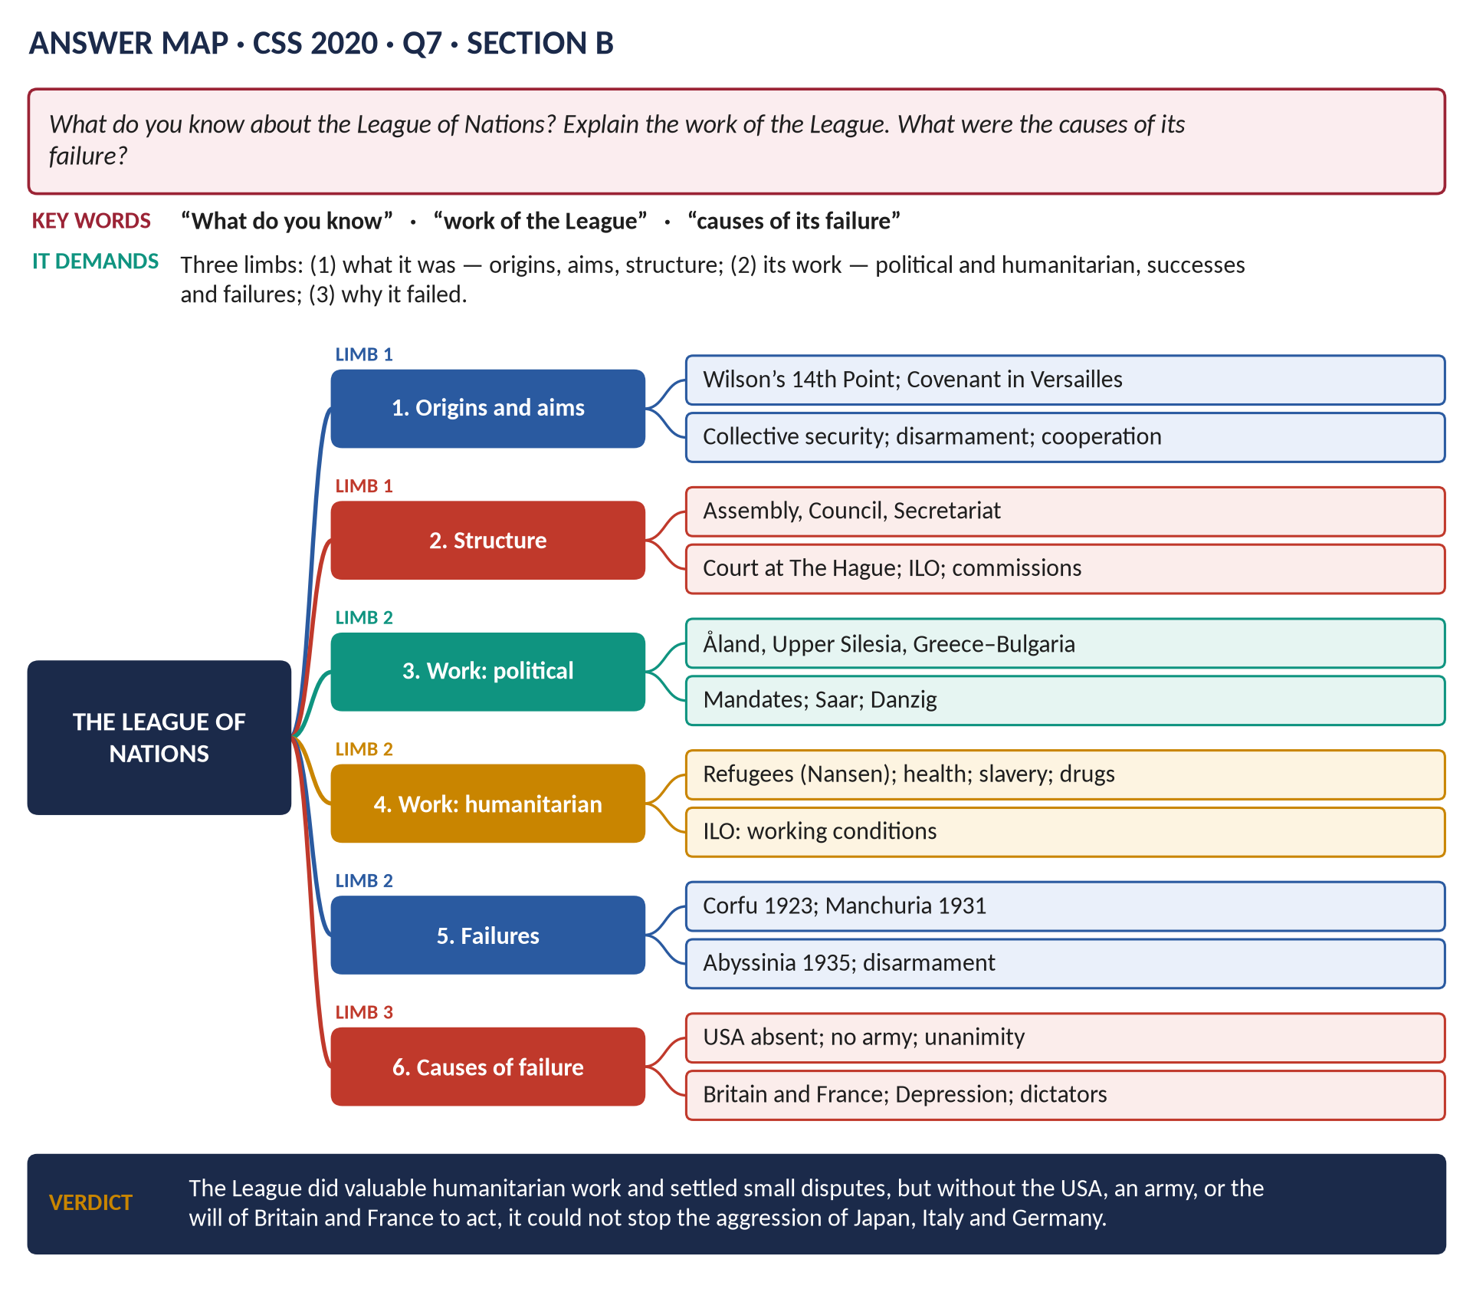
Figure 13 · The answer map for CSS 2020 · Q7 · Section B: every branch is one heading of the answer below.
DECODING THE QUESTION
Three limbs. (1) "What do you know about the League of Nations?" — its origins, aims, structure and membership. (2) "Explain the work of the League" — what it actually did: political disputes (successes and failures) and its humanitarian and social work. (3) "What were the causes of its failure?" — the reasons, numbered and weighed.

The model answer

Introduction
The League of Nations was the first worldwide organisation of states created to keep the peace. Founded in 1920 as part of the peace settlement after the First World War, it aimed to prevent war through collective security, settle disputes by discussion and improve the lives of people everywhere. It did valuable humanitarian work and settled several disputes between small states, but in the 1930s it failed to stop the aggression of Japan, Italy and Germany. It failed chiefly because the USA never joined, it had no armed force, and its leading members, Britain and France, would not risk war to enforce its decisions.
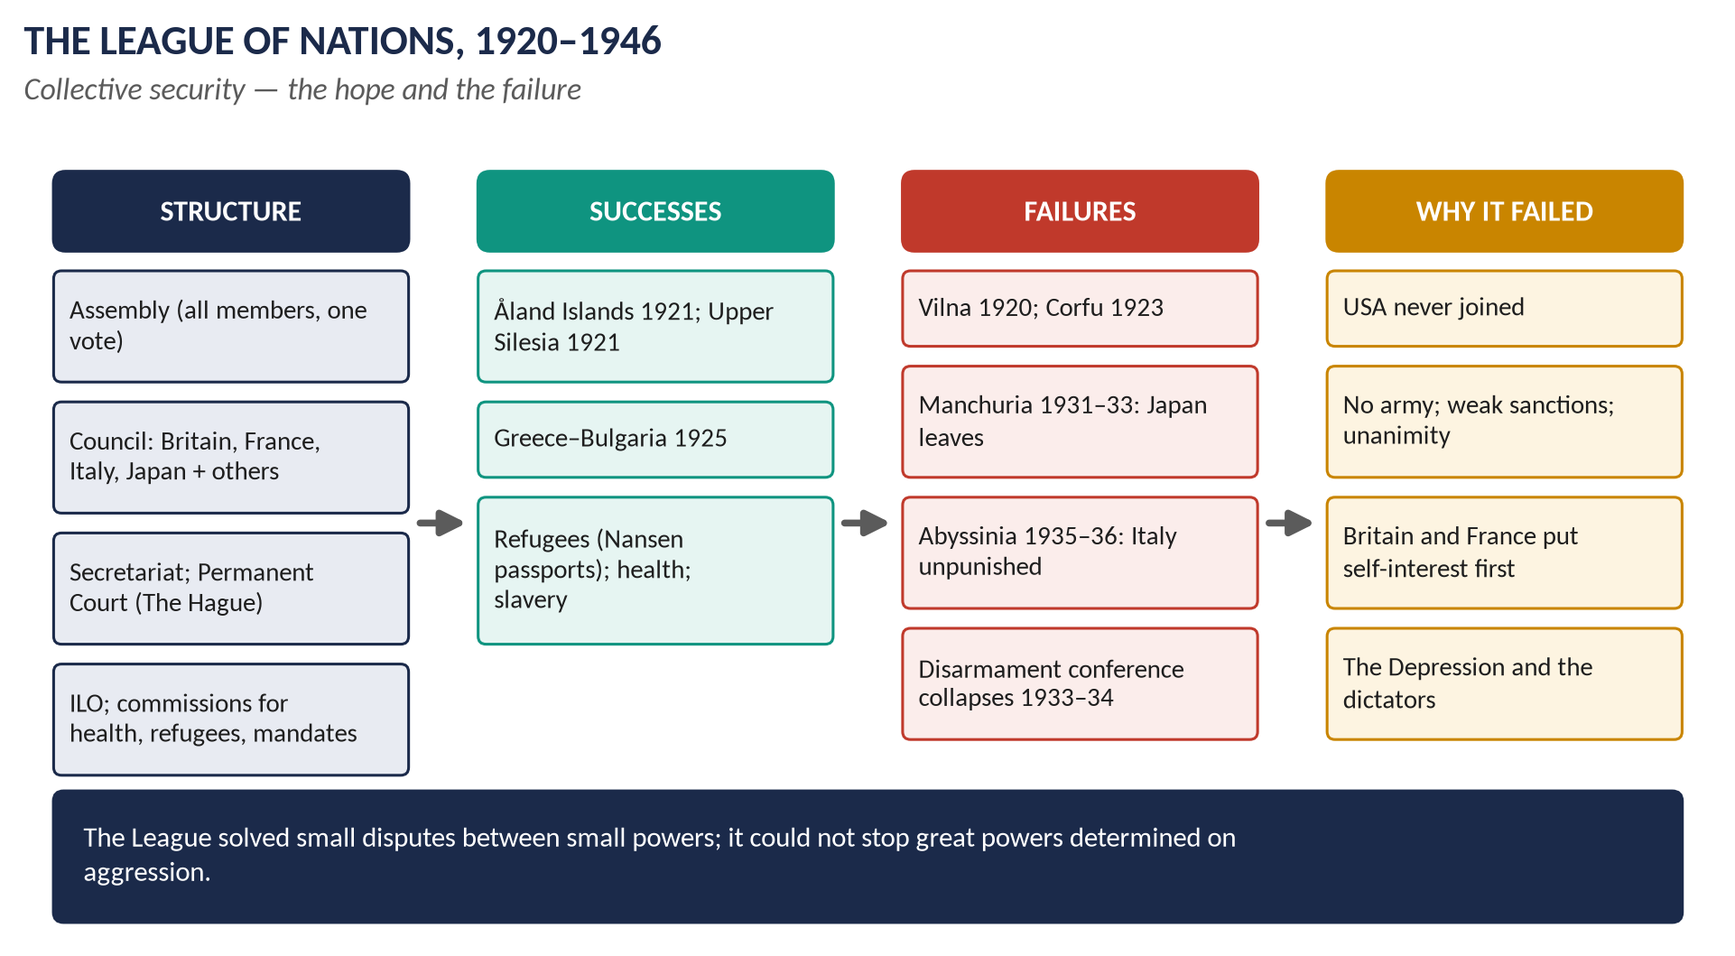
Figure 14 · The League of Nations.

Limb 1 · What the League was

(1) Origins
- Woodrow Wilson, President of the USA, made "a general association of nations" the last of his Fourteen Points (January 1918).
- In Britain, Lord Robert Cecil, Jan Smuts and the League of Nations Union were strong supporters.
- The Covenant of the League (26 articles) was written into the Treaty of Versailles and the other peace treaties.
- The League came into existence on 10 January 1920; its headquarters were in Geneva, Switzerland.

(2) Aims
1. Collective security: an attack on one member would be treated as an attack on all.
2. Settling disputes peacefully by arbitration and judgement.
3. Disarmament.
4. Improving social and economic conditions — health, labour, refugees.
5. Supervising the mandates (the former German and Turkish territories).

(3) Structure
Organ | Role
The Assembly | All members; one vote each; met once a year; decisions usually unanimous.
The Council | Permanent members Britain, France, Italy, Japan (Germany 1926–33, USSR 1934–39) plus elected members; dealt with crises.
The Secretariat | The League's civil service.
The Permanent Court of International Justice | At The Hague; judged legal disputes between states.
The International Labour Organisation | Improved working conditions.
Commissions | Mandates, refugees, health, slavery, drugs, disarmament.

(4) Powers — the sanctions of Article 16
1. Moral condemnation.
2. Economic sanctions — members would stop trading with an aggressor.
3. In theory, military action — but the League had no army; it depended on members sending forces.

(5) Membership
42 founding members; a peak of 58 (1934–35). The USA never joined — the US Senate refused to ratify the Treaty of Versailles. Germany joined in 1926; the USSR in 1934. Japan and Germany left in 1933, Italy in 1937.

Limb 2 · The work of the League

(6) Political successes (the 1920s)
1. The Åland Islands (1921): Sweden and Finland both claimed them; the League gave them to Finland with protection for the Swedish-speaking inhabitants — both accepted.
2. Upper Silesia (1921): after a plebiscite the League divided it between Germany and Poland.
3. Albania (1921): Yugoslav troops were persuaded to withdraw.
4. Greece and Bulgaria (1925): after a border incident at Petrich, Greece invaded Bulgaria; the League ordered a ceasefire and made Greece pay compensation — war was prevented.
5. Mosul (1926): awarded to Iraq (a British mandate) rather than Turkey.
6. The Saar (1920–35): governed fairly by the League; a plebiscite returned it to Germany (1935).
7. Austria and Hungary: financial rescue (1922–23).

(7) Humanitarian and social work
1. Refugees and prisoners of war: Fridtjof Nansen returned about 400,000 prisoners of war to their homes and created the "Nansen passport" for stateless refugees (Nobel Peace Prize, 1922).
2. Health: campaigns against leprosy, malaria, typhus and cholera — the forerunner of the World Health Organisation.
3. Slavery: about 200,000 slaves freed in Sierra Leone; action against forced labour.
4. Drugs: controls on the trade in opium and other drugs.
5. The ILO: campaigns for the 48-hour week, an end to child labour, and workers' rights.
6. The mandates: reports on how Britain, France and others governed their mandated territories.

(8) Failures
1. Vilna (1920): Poland seized it from Lithuania; the League did nothing.
2. Corfu (1923): Mussolini bombarded and occupied Corfu after an Italian general was murdered; the League made Greece pay compensation — a victory for the bully.
3. Manchuria (1931–33): Japan invaded China's northern province. The Lytton Report (1932) condemned Japan, which simply left the League (1933) and kept Manchuria.
4. Disarmament (1932–34): the conference failed; Germany walked out and left the League (October 1933).
5. Abyssinia (1935–36): Italy invaded Ethiopia, a League member. Sanctions were imposed but not on oil, and Britain did not close the Suez Canal; the Hoare–Laval Pact (December 1935) secretly offered Italy two-thirds of Abyssinia. Italy conquered the country (May 1936). The League never recovered.
6. 1936–39: the League was ignored over the Rhineland, Spain, Austria, Czechoslovakia and Poland.

Limb 3 · The causes of its failure

(9) Structural weaknesses
1. The USA was absent: the world's richest power never joined, so economic sanctions could be evaded by trading with America.
2. No army: the League depended on members to supply forces — and they would not.
3. Unanimity: the Assembly and Council usually needed all members to agree, making action slow or impossible.
4. Weak sanctions: economic sanctions were slow and partial.
5. Slow procedures: the Lytton Commission took a year to report on Manchuria.

(10) Membership problems
The defeated powers (Germany until 1926) and the USSR (until 1934) were excluded at first; the aggressors — Japan, Germany, Italy — simply left when criticised.

(11) The self-interest of Britain and France
- The two leading members put national interest before the League: Britain would not risk war with Japan over Manchuria or with Italy over Abyssinia, and wanted Italy as an ally against Germany (Stresa, 1935).
- The Hoare–Laval Pact showed that Britain and France were ready to reward aggression behind the League's back.
- Both were weakened by the war, debts and the Depression.

(12) The Great Depression
The slump of 1929–33 made countries selfish and protectionist, reduced support for sanctions, and helped aggressive nationalist regimes to power in Germany and Japan.

(13) The dictators
Hitler, Mussolini and the Japanese militarists were determined on expansion and did not care about world opinion or moral condemnation.

(14) Linked to Versailles
The League was part of a peace treaty that the defeated regarded as unjust; Germany saw it as the victors' club.
KEY IDEA · The deepest cause
The League could only be as strong as the will of its great members. When Britain and France — the only great powers who led it throughout — would not risk war to stop an aggressor, collective security collapsed.

(15) Its legacy
The League was dissolved in April 1946. Its lessons shaped the United Nations (1945), which included the USA and the USSR, gave great powers a Security Council veto, and could call on member states' armed forces. Its humanitarian bodies lived on — the ILO, and the WHO and the UNHCR as successors of its health and refugee work.
VERDICT · Conclusion
The League of Nations was a brave attempt to replace power politics with collective security. In the 1920s it settled disputes between small states and did outstanding humanitarian work for refugees, health and workers. But it lacked the USA, an army and effective sanctions, and it depended on Britain and France, who put their own interests first. When Japan, Italy and Germany challenged it in the 1930s, it could not act, and it failed — though its ideals and many of its agencies survived in the United Nations.

WHY THIS ANSWER SCORES · Why this answer scores
All three limbs clearly separated · Limb 1 covers origins, aims, structure, powers and membership (a table) · Limb 2 explains the work — political successes, humanitarian work (often forgotten) and failures, all dated · Limb 3 groups and ranks the causes with a key box · a note on the legacy (UN) completes it.

Part Two — The Past MCQs, Solved

CSS 2024 · MCQ 5
The Treaty of Versailles was signed on:
(A) 21 June 1919 | (B) 22 June 1919 | (C) 28 June 1919 | (D) None of these

REMEMBER · Answer: C. 28 June 1919
The Treaty of Versailles was signed on 28 June 1919 in the Hall of Mirrors at Versailles — exactly five years after the assassination at Sarajevo.

CSS 2024 · MCQ 6
How many British Prime Ministers served during World War I?
(A) Two | (B) Three | (C) One | (D) None of these

REMEMBER · Answer: A. Two — H. H. Asquith and David Lloyd George
Two Prime Ministers led Britain in the First World War: H. H. Asquith (1908 – December 1916) and David Lloyd George (December 1916 – 1922).

CSS 2024 · MCQ 20
King Edward VIII announced his abdication from the British throne on:
(A) 14 December 1936 | (B) 12 December 1936 | (C) 11 December 1936 | (D) None of these

REMEMBER · Answer: C. 11 December 1936
Edward VIII signed the Instrument of Abdication on 10 December 1936; the Abdication Act passed and he announced his abdication to the nation by radio on 11 December 1936.

CSS 2025 · MCQ 9
Which monarch gave the Edwardian era its name?
(A) Victoria | (B) George VI | (C) Edward VII | (D) None of these

REMEMBER · Answer: C. Edward VII
The Edwardian era takes its name from King Edward VII, who reigned from 1901 to 1910.

CSS 2025 · MCQ 12
What was Britain's policy toward Nazi Germany in the late 1930s called?
(A) Containment | (B) Deterrence | (C) Appeasement | (D) None of these

REMEMBER · Answer: C. Appeasement
Britain's policy of trying to satisfy Nazi Germany's demands to avoid war (1935–39) was called appeasement.

CSS 2026 · MCQ 18
The policy of appeasement is most closely associated with:
(A) Winston Churchill | (B) Neville Chamberlain | (C) Clement Attlee | (D) None of these

REMEMBER · Answer: B. Neville Chamberlain
Appeasement is most closely associated with Neville Chamberlain, Prime Minister 1937–40, who signed the Munich Agreement (1938).

Part Three — Five Predicted Questions, with Outlines
WHAT THE EXAMINER HAS ASKED · Why these five
They cover parts of syllabus Heads X–XI not yet set as full questions.

Predicted 1 · "Discuss the Liberal reforms of 1906–1914. Did they lay the foundations of the welfare state?"
- Why: poverty surveys; New Liberalism; national efficiency; the Labour threat; Lloyd George and Churchill.
- Reforms: children (1906–08); pensions (1908); workers (1906–09); the People's Budget (1909); National Insurance (1911).
- Foundations? Yes — the state's responsibility for the old, sick, unemployed and children; the model for Beveridge. But limited coverage and benefits; no health cover for families; insurance-based.
- Verdict: the first storey of the welfare state.

Predicted 2 · "Examine the constitutional crisis of 1909–1911 and the significance of the Parliament Act."
- Causes: the Lords' Conservative majority; rejection of Liberal bills; the People's Budget rejected (1909).
- Crisis: two elections (1910); the King's promise to create peers; the Lords yield (1911).
- The Act: no delay to money bills; two-year delay; five-year parliaments; MPs paid.
- Significance: the supremacy of the Commons; Home Rule and Welsh disestablishment possible; the Lords weakened further in 1949 and 1999.

Predicted 3 · "Assess the role of Britain in the Paris Peace Settlement of 1919."
- Aims of Lloyd George: security, the German fleet, empire, reparations, but a Germany able to trade; the Fontainebleau Memorandum.
- Terms of Versailles and the other treaties.
- Britain's gains: navy, mandates, the League.
- Judgement: Keynes's "Carthaginian peace"; Foch's "armistice"; MacMillan's defence.

Predicted 4 · "What were the causes and consequences of the General Strike of 1926?"
- Causes: coal's decline; the gold standard (1925); the owners' demands; Red Friday (1925); the Samuel Commission; "Not a penny off the pay…".
- Events: 4–12 May 1926; the TUC; the government's preparations; the British Gazette; the BBC.
- Consequences: defeat for the miners; the Trade Disputes Act (1927); union decline and moderation; Labour's growth.

Predicted 5 · "Explain the impact of the Great Depression on Britain and the government's response."
- Causes: the Wall Street Crash (1929); the world slump; the weakness of Britain's old industries.
- Impact: ~3 million unemployed (1932–33); the depressed areas (Jarrow); the 1931 crisis; two Britains.
- Response: the National Government; benefit cuts and the means test; leaving the gold standard; tariffs (1932) and Ottawa; cheap money; the Special Areas Act (1934).
- Verdict: a slow, orthodox recovery that helped the south more than the north.

